PARITY PATTERNS AND MATERNAL PROFILES: INSIGHTS FROM SRI LANKA’S VITAL STATISTICS SYSTEM

Sooriya Arachchige Dhanushka Prabhath Samarawickrama

University of Sri Jayewardenepura, Sri Lanka

PARITY PATTERNS AND MATERNAL PROFILES: INSIGHTS FROM SRI LANKA’S VITAL STATISTICS SYSTEM

A thesis
Submitted for the Industrial based Project (ASC 408 10.0) to
The Department of Statistics of the
University of Sri Jayewardenepura
In partial fulfillment of the
Requirements for the
Bachelor of Science (Honours) Degree in Applied Science
In the field of Statistics.

By
S.A.D.P. Samarawickrama
University of Sri Jayewardenepura
May 2026
DECLARATION
The work described in this thesis was carried out by me in collaboration with Accenture and the Department of Statistics, University of Sri Jayewardenepura, Sri Lanka under the guidance of Dr. Chathuri Jayasinghe and Mr. P. Dias and has not been submitted elsewhere.

……………………... ……5.31.2026………
S.A.D.P.Samarawickrama Date of submission

………………………….. ………………………..
Dr. Chathuri Jayasinghe Mrs. B.H.Pushpa Kumari
Internal Supervisor External Supervisor
University of Sri Jayewardenepura Registrar General’Department

…………………………….
Dr. Rajitha M. Silva
Head of the Department
Department of Statistics
Faculty of Applied Sciences
University of Sri Jayewardenepura

Acknowledgement
I would like to express my sincere gratitude to my supervisors, Senior Lecturer Dr. Chathuri Jayasinghe, for their invaluable guidance, continuous encouragement, and constructive feedback throughout this research study. Their expertise, patience, and support greatly contributed to the successful completion of this project.
I would also like to express my sincere thanks to my external supervisor, Mrs. B.H.Pushpa Kumari, for her valuable guidance and support. Furthermore, I am thankful to the Statistics branch of the Registrar General’s Department for their encouragement, flexibility, and understanding, which enabled me to balance both my professional responsibilities and academic work successfully.
I am deeply grateful to my family for their unconditional love, encouragement, patience, and understanding throughout my academic journey. Their constant support and belief in me have been a great source of strength and motivation.
My heartfelt appreciation also goes to my friends and colleagues for their encouragement, motivation, and companionship during challenging times. Their support and kindness made this journey more meaningful and memorable.
Finally, I would like to thank everyone who contributed directly or indirectly to the successful completion of this research study. Their support and encouragement are sincerely appreciated.

List of Abbreviations
Acronym | Description
CRVS | Civil Registration Vital Statistic
WHO | World Health Organization
UN | United Nation
DHS | Demographic Health Survey
ART | Assisted Reproductive Technology
LBW | Low Birth Weight
VLBW | Very Low Birth Weight
ELBW | Extreme Low Birth Weight
ACOG | American College of Obstetricians And Gynecologists
GVIF | Generalized Variance Inflation Factor
POM | Proportional Odds Model
AIC | Akaike Information Criterion
BIC | Bayesian Information Criterion
IRR | Incidence Rate Ratios
AUC | Area Under the Curve
ROC | Receiver Operating Characteristic
OR | Odds Ratios
AMA | Advanced Maternal Age
SLDHS | Sri Lanka Demographic and Health Survey

Table of Contents
1 Introduction 11
1.1 Background and Significance 13
1.1.1 Parity as a demographic indicator 13
1.1.2 Demographic transition theory and its application 15
1.1.3 Sri Lanka’s demographic transition 15
1.1.4 Sri Lanka’s Civil Registration and Vital Statistics System 16
1.1.5 Significance of the Study 17
1.2 Literature Review 19
1.2.1 Global Perspectives on Parity and Fertility Transition 19
1.2.2 Fertility Transitions in South Asia 21
1.2.3 Maternal Age, Parity, and Birth Outcomes 22
1.2.4 Birth Weight and Parity 23
1.2.5 Sex of the Child, Gender Preferences, and Parity Progression 24
1.2.6 Female Education, Socioeconomic Status, and Parity 25
1.2.7 Multiple Births: Associations with Maternal Age and Parity 26
1.2.8 Marital status, non-marital fertility, and parity 26
1.2.9 Place of Delivery and Associated Maternal Characteristics 27
1.2.10 Ethnicity and Fertility Differentials 28
1.3 Research Gaps and Justification for the Present Study 28
1.4 Objective of The Study 29
1.4.1 Main Objective 30
1.4.2 Specific Objectives 30
1.5 Chapter Summary 31
2 Methodology 32
2.1 Research Design 32
2.2 Data Source and Study Population 33
2.3 Dataset Structure and Scope 34
2.4 Description of Variables 35
2.4.1 Outcome Variable: Parity 36
2.4.2 Explanatory Variables 37
2.4.3 Geographic and Administrative Variables 40
2.5 Data Preparation and Cleaning 40
2.5.1 Variable Recoding 41
2.5.2 Missing Variable Analysis 41
2.5.3 Outlier Analysis 42
2.6 Statistical Methods 46
2.6.1 Descriptive Statistics 47
2.6.2 Chi-Square Tests of Association 47
2.6.3 Regression Model Selection 48
2.7 Model Comparison and Selection 52
2.8 Ethical Considerations 53
2.9 Limitations of the Methodology 53
3 Results and Discussion 55
3.1 Missing analysis 55
3.2 Outlier Analysis 57
3.2.1 Outlier analysis of Age of Mother 57
3.2.2 Outlier analysis of Birth Weight 58
3.3 Descriptive analysis 59
3.3.1 Distribution of parity (birth order) 59
3.3.2 Maternal Charestics 71
3.4 Model Fitting 73
3.4.1 Pre-Modelling Diagnostics 73
3.4.2 Model 1: Ordinal Logistic Regression (Proportional Odds Model) 76
3.4.3 Model 2: Poisson Regression 81
3.4.4 Model 3: Binary Logistic Regression 86
3.4.5 Model Comparison and Summary 90
4 Conclusion 91
4.1 Summary of Key Findings 91
4.1.1 Distribution and Characteristics of First-Born and Later-Born Children 91
4.1.2 Maternal Characteristics Associated with Parity 91
4.1.3 Regression Modelling and Factors Independently Associated with Parity 92
4.2 Limitations of the Study 92
4.3 Recommendations for Future Research 93
4.4 Chapter Summary 93

Abstract
Parity, defined as the number of live births a woman has had, is a fundamental demographic indicator for understanding fertility behavior and population dynamics. Even with rich civil registration data available in Sri Lanka, few studies have focused on analyzing parity using vital statistics. This study dives into the demographic, maternal, and birth-related factors associated with parity in Sri Lanka and also focuses on the distinction between first-born and later-born children, using birth registration data from the Registrar General’s Department for five selected years: 2000, 2005, 2010, 2015, and 2020.
This study used a quantitative, cross-sectional approach, drawing on secondary data from Sri Lanka’s Civil Registration and Vital Statistics system, comprising around 1.7 million registered live birth records. Birth order served as the primary outcome variable. Explanatory variables included maternal age, marital status, ethnicity, child’s sex, place of delivery, multiple birth status, birth weight, and province of the mother. In this study, descriptive analysis and regression models, including ordinal logistic regression, Poisson regression, and binary logistic regression, were applied.
Results show that most births in Sri Lanka now fall at lower parities, such as first and second. Total Fertility Rate declined from 2.27 in 2005 to 1.62 in 2020, confirming below replacement fertility. Regression modelling using data from 2010, 2015, and 2020 identified maternal age as the strongest and most consistent predictor of parity across all three approaches. The study concludes that Sri Lanka has reached an advanced stage of demographic transition characterized by increasing concentration of births at lower parities and delayed childbearing. These findings show the analytical value of Sri Lanka’s CRVS systems for population-level demographic research.
Keywords: Parity, Birth Order, Fertility Transition, Civil Registration and Vital Statistics, Sri Lanka, Maternal Age, Logistic Regression, Poisson Regression, Demographic Transition, Vital Statistics

1 Introduction
Parity, defined as the number of live births a woman has had, is a fundamental demographic indicator that reveals fertility behavior, maternal life courses, and population – level transformations (Bongaarts, 1998). The analysis of birth order gives critical and useful insight into family formation patterns, reproductive timing, and the socio-demographic factors that scale childbearing decisions across populations. In particular, the distinction between firstborn (parity =1) and higher order births (parity ≥ 2) serves as a meaningful analytical approach for understanding how fertility preferences and behaviors changed over time (Zeman et al., 2018) Parity-specific analysis moves beyond aggregate fertility measures to examine the mechanisms behind fertility decline: changes in when women have their first child, whether they go on to have more children, and how the composition of the childbearing population shifts over time.
Firstborn children are demographically significant because they mark the transition to parenthood and reflect the social behaviors, economic conditions, and institutional factors that shape the decision to start a family (Bongaarts, 2002). The age at which women begin childbearing, the circumstances of the birth, and the maternal profile of first pregnancies are all indicators of broader social change. Shifts in the proportion and characteristics of first births relative to higher-order births can affect fertility transitions such as delayed marriage, rising educational attainment among women, changing family size preferences, and new attitudes toward parenthood (Lesthaeghe, 2014). Understanding these shifts matters for both demographic research and the planning of maternal and child health services.
Higher-order births also carry important information about reproductive health and population dynamics. Research has shown that higher-order births are associated with specific maternal profiles, including older maternal age, shorter birth intervals in some populations, and uneven access to health services (Kozuki et al., 2013). The relationship between parity and birth outcomes, including birth weight, gestational age, and mode of delivery, has been extensively studied in clinical and epidemiological research, revealing complex interactions between biological, social, and healthcare factors (Lean et al., 2017).These findings imply the importance of parity as a variable of interest in both demographic analysis and public health planning.
Sri Lanka has one of the most well-established Civil Registration and Vital Statistics (CRVS) systems among developing countries, with origins dating to 1992 and birth registration with publications(Department of Census & Statistics, 2025). The system records a wide range of variables for each birth: birth order, child’s sex, multiple birth status, place of delivery, birth weight, maternal age, marital status, and parental ethnicity. This administrative dataset provides population-level, continuous demographic information not subject to the sampling limitations of surveys like the Demographic and Health Surveys (DHS). Because of the availability of this data, most fertility research in Sri Lanka has relied on census data or periodic DHS surveys, leaving the potential of vital statistics data largely untapped for parity research. Sri Lanka’s vital statistics data can be a powerful tool for parity analysis, with the advantages of complete population coverage, temporal continuity, and administrative variables not always available in survey instruments.
The study addresses this research gap by analyzing birth registration data from four selected years: 2000, 2005, 2010, 2015, and 2020 to examine parity patterns and associated maternal and birth characteristics. The five-year intervals allow for the identification of temporal trends during a period of significant demographic change in Sri Lanka. The study combines descriptive statistics, chi-square tests, and binary logistic regression. The descriptive component characterizes the distribution of first-born and later-born children. The inferential component identifies factors independently associated with parity classification.
The rest of this chapter is organized as follows. Section 1.2 covers the background and significance of the study, including parity as a demographic indicator, demographic transition theory, Sri Lanka’s specific transition, the country’s CRVS system, and the significance of the research. Section 1.3 reviews the relevant literature across global perspectives on parity and fertility, maternal age and parity, birth weight, gender preferences, multiple births, marital status, place of delivery, ethnicity, Sri Lanka-specific research, civil registration data, and the application of cluster analysis and logistic regression. Section 1.4 states the objectives, and Section 1.5 summarizes the chapter.

1.1 Background and Significance
The background and significance section provides the contextual foundation for the study by explaining the broader demographic health importance of the research problem. It highlights existing knowledge, identifies research gaps, and justifies the importance of examining parity patterns and maternal characteristics in Sri Lanka for demographic analysis.

1.1.1 Parity as a demographic indicator
Parity, or birth order, is one of the most fundamental measures in demographic analysis, offering a direct view of individual reproductive histories and aggregate fertility patterns. Unlike summary measures such as the total fertility rate, which provide a cross-sectional view of age-specific fertility, parity-specific indicators capture the sequential process by which women build their families over their reproductive lives (Zeman et al., 2018). This process evaluates the importance of understanding how fertility transitions, since the shift from high to low. The difference between the firstborn and the later-born children is important from both demographic and public health perspectives. First births represent the entry into parenthood and are influenced by a distinct set of factors: the timing of partnership formation, educational and career paths, housing availability, and cultural standards about when and how to start a family (Ní Bhrolcháin & Beaujouan, 2012)The age at first birth has been rising in most developed and many developing countries, with significant implications for completed family size, maternal health, and the composition of the childbearing population (Sobotka, 2017). Higher-order births shaped the experience of previous pregnancies, birth spacing decisions, and economic resources, and the desire for a particular family size or sex composition.
In the context of low and declining fertility, the changing parity composition of births has implications for population structure. As higher-order births become less common, first and second births account for a growing share of all births, which alters the aggregate risk profile of the childbearing population. In economically advanced settings, observed that roughly 75 to 90 per cent of all births are first or second births, reflecting the distribution of small-scale family structures(Bongaarts, 2002). This concentration at lower parities may affect population ageing, dependency ratios, and intergenerational resource transfers, making parity analysis relevant not just for demographic research but also for social and economic policy.

1.1.2 Demographic transition theory and its application
Demographic transition theory provides the foundational framework for understanding long-term shifts in fertility and mortality. The classical formulation, attributed mainly to, describes a progression from pre-transitional details of high fertility and high mortality. The mechanisms behind fertility decline within the transition framework are multiple and interrelated. Socio-economic development, urbanization, rising educational attainment (especially among women), declining infant and child mortality, increased access to modern contraception, and changing values about family size have all been identified as contributing factors.
Within demographic transition theory, parity analysis helps to understand the micro-level mechanisms behind fertility change. The shift from high to low fertility involves not just fewer births overall but a restructuring of parity distributions: higher-order births decline and childbearing becomes concentrated at lower parities. The timing of these changes varies across populations and is influenced by both structural factors (economic development, access to family planning) and ideational factors (family size preferences, gender norms). By examining parity patterns and associated maternal characteristics across selected years, this study contributes to understanding these processes in Sri Lanka.

1.1.3 Sri Lanka’s demographic transition
Sri Lanka’s demographic transition is widely regarded as one of the most remarkable among developing nations, marked by rapid fertility decline. The country’s experience has been frequently cited as a model of how investments in human capital, education, and health in particular, can drive demographic change even without high levels of economic development (Caldwell, 1986). The implications for parity distributions are significant: as overall fertility falls, births shift increasingly toward first and second parities, and higher-order births become rarer. Understanding these parity shifts and the maternal characteristics associated with them is necessary for adapting health services, social policies, and demographic planning. This study, by examining birth registration data from 2000 to 2020, captures a critical period of this evolution and provides empirical evidence that can inform policy responses.
The differential pace of fertility change across population subgroups has additional implications. If fertility declines more rapidly among certain ethnic, geographic, or socioeconomic groups, the resulting disparities in parity distributions may affect health equity and the allocation of maternal health resources. For instance, if higher-order births become increasingly concentrated among minority groups or disadvantaged populations while the majority’s births cluster at lower parities, the health system may need differentiated service models. This study’s examination of parity patterns by maternal characteristics and ethnicity provides evidence relevant to understanding these equity-related dimensions of fertility change.

1.1.4 Sri Lanka’s Civil Registration and Vital Statistics System
Sri Lanka has one of the oldest and most well-established civil registration systems among developing countries, which is maintained by the Registrar General’s Department of Sri Lanka. Every live birth must be registered within 42 days at the registrar’s division where the birth took place. Registration happens at the place of occurrence rather than the mother’s area of residence, which matters for geographic analysis of birth data.
The system records a wide range of variables for each live birth, including administrative identifiers (district, registrar’s division), demographic variables (date of birth, child’s sex, birth order), health variables (multiple birth status, place of delivery, birth weight), and parental characteristics (mother’s date of birth, marital status, parental ethnicity). This makes the data well-structured for parity analysis, since it allows both child and maternal characteristics to be examined in relation to birth order. The data go through a systematic processing approach that is managed by the Statistics Branch of the Registrar General’s Department, including acceptance of completed forms, visual checking, coding, data entry, computerized edit programs for each district batch, error reports, corrections, and production of final statistical tabulations.
Sri Lanka’s vital statistics system has not been much used for detailed parity-based research. Most published fertility studies have relied on the DHS (Demographic Health Survey), which provides valuable but periodic and sample-based insights. While the DHS collects a wide range of health, behavioral, and attitudinal variables not available in vital statistics, the vital statistics offer complementary advantages: complete population coverage (eliminating sampling bias), continuous temporal coverage (enabling year-by-year trends), and administrative geographic identifiers (facilitating spatial disaggregation). This study seeks to demonstrate these advantages.

1.1.5 Significance of the Study
This study contributes to the existing literature by using Sri Lanka’s vital statistics system to generate national-level evidence on the parity pattern. By examining data from 2000 to 2020, the study captures a period of substantial demographic change, including the later stages of fertility decline. This temporal scope allows for the identification of trends that would not be seen from a single-year analysis. The study contributes to several sections. First, documenting changes in the distribution and characteristics of first-born and later-born children over selected years provides an empirical basis for understanding how parity structures behave in demographic transition. Such evidence is currently lacking in the Sri Lankan research context, where parity-specific analysis of vital statistics has not been conducted. Identifying maternal characteristics associated with different parity levels is another use of this study because factors like age at birth, marital status, and ethnicity provide evidence relevant to maternal and child health planning. As the childbearing population changes with demographic transition, maternity care must adapt accordingly, and understanding the changing profiles of first-time and experienced mothers is necessary for that adaptation. Use of regression modeling helps identify factors independently associated with parity classification, contributing methodologically to the growing body of work using administrative data for demographic research. This approach, widely used in parity research internationally (Hosmer et al., 2013), allows estimation of adjusted effects while controlling for confounders, providing more robust evidence than description alone.
Finally, the study demonstrates the analytical value of administrative vital statistics for demographic research in Sri Lanka. By showing that rich and policy-relevant insights can come from existing vital statistics records, it supports international calls for greater use of CRVS systems in population research (United Nations, 2014).This is particularly timely given Sri Lanka’s ongoing transition to a digital CRVS platform, which should further enhance the accessibility and analytical potential of these data.

1.2 Literature Review
This section reviews the relevant literature, organized around the key themes of the study. The review covers a global perspective on parity and fertility transition, childbearing postponement, maternal age and parity interactions, birth weight and parity, sex of the child and gender preferences, multiple births, marital status, place of delivery, ethnicity, and fertility differentials. Addressing parity research in the South Asian context and Sri Lanka specifically, and concluding with a review of the statistical methods employed in parity research. Where available, recent studies are prioritized to ensure the relevance of the reviewed literature to contemporary demographic conditions.

1.2.1 Global Perspectives on Parity and Fertility Transition
The study of parity patterns has been central to understanding fertility transitions worldwide. Demographic transition theory describes how societies move from high fertility and mortality to low fertility and mortality (Kirk, 1996). Within this framework, parity-specific analysis provides a more detailed view of how fertility decline actually works. Rather than treating fertility as a single aggregate situation, parity analysis examines how women’s progression through successive births changes over time, revealing the parities at which reproductive behavior is most responsive to social, economic, political, and cultural change.
Fertility and reproductive preferences in post-transitional societies are influenced by several factors that contribute to the gap between desires and actual fertility. In most developed countries, the desired family size generally converges around two children, and actual fertility often remains below this level. This effect was considered particularly important because increasing the age at pregnancy temporarily depresses period fertility measures such as the Total Fertility Rate (TFR), and in many countries its appear lower than completed cohort fertility (Bongaarts, 1998).
The end of the fertility transition in developed countries has been examined in relation to differences between period and lifetime fertility measures. Although period indicators in many European countries suggested extremely low fertility levels. Fertility by birth order further showed that post-transitional fertility patterns were increasingly concentrated at lower parities, with first and second births accounting for the majority of all births (Bongaarts, 2002). These findings suggest that countries undergoing fertility transition, such as Sri Lanka, may also experience a growing concentration of births at lower parities as fertility declines. In Southern Europe, declining progression from first to second birth was a major factor. In English-speaking countries and Western Europe, reduced progression to third and higher order births predominated. In East Asia, both rising childlessness and declining higher-order births contributed. These findings demonstrate the necessity of parity-specific analysis for understanding the diverse pathways to low fertility (Zeman et al., 2018).
Parity-specific fertility differences across educational groups in low-fertility countries were later explored, revealing that the relationship between education and fertility varies by birth order. Highly educated women were found to be more likely to remain childless or to have only one child, while educational differences in progression to third and higher-order births varied across countries (Brzozowska et al., 2022). The study demonstrated increasing diversity in family size patterns within low-fertility populations and challenged the assumption that two-child families dominate uniformly, thereby reinforcing the importance of disaggregated parity analysis.
Fertility transitions in low- and middle-income countries have also been examined in relation to reproductive preferences and fertility decline (Bongaarts, 2025). Based on the evidence from the Demographic and Health Survey (DHS) data across developing countries indicates that declining fertility accounts for a substantial proportion of fertility reduction in the Global South. Countries with strong family policies, such as the Nordic nations, maintained a higher progression ratio to second and third births compared to weaker policy support, such as those in Southern Europe(Frejka & Sardon, 2007). At the same time, birth control initiation plays a complementary but less dominant role. This framework is particularly relevant for transitional societies such as Sri Lanka, where changing reproductive preferences and their implementation influence the distribution of births across different parities.

1.2.2 Fertility Transitions in South Asia
Sri Lanka's demographic experience is very interesting when compared with the rest of South Asia. This region has seen some changes in the number of children women have, and it is different from country to country. All major countries in South Asia have seen a decrease in the number of children since the 1960s because the social and economic conditions, as well as the policies and culture, are not the same in every country (Bongaarts, 2025).
The factors behind Sri Lanka’s earlier transition are discussed as early and sustained investment in health and education, including free education and comprehensive public health infrastructure (Caldwell, 1986).
The implication for parity distribution across Asian countries follows directly. In countries like Sri Lanka, parity distribution is heavily concentrated at first and second births. In countries with higher fertility, it will be more dispersed, with more births at higher parities. These differences matter for maternal and child health profiles, obstetric service requirements, and demographic policy planning.

1.2.3 Maternal Age, Parity, and Birth Outcomes
The relationship between maternal age, parity, and birth outcomes has been one of the most widely examined in demographic and perinatal epidemiological research. Advanced maternal age (AMA), normally defined as 35 years or older at delivery, has been consistently associated with risks of adverse pregnancy and birth outcomes (Kenny et al., 2013; Lean et al., 2017). Using some singleton births in the United Kingdom, examined the relationship between advanced maternal age and adverse pregnancy outcomes. Applying log-linear binomial regression models adjusted for parity, ethnicity, social deprivation, and body mass index, they found that women aged 40 and above were at significantly increased risk of stillbirth (relative risk 1.83), preterm birth (RR 1.25), very preterm birth (RR 1.29), macrosomia (RR 1.31), and caesarean delivery (RR 1.83) compared to women aged 20–29 (Kenny et al., 2013). These risks remained significant after adjustment for parity and other potential confounders.
The combined effects of maternal age and parity on maternal and infant health outcomes were further explored in a South African study using multivariable regression analysis. The findings revealed that while nulliparous women exhibited the highest likelihood of delivering low birth weight and small for gestational age infants, older multiparous women (> 23 years) faced significantly higher metabolic risks, including elevated BMI, gestational diabetes, and hypertension and also younger multiparous women demonstrated the most favorable infant birth weight and length profiles, suggesting a protective effect of prior reproductive experience when combined with younger maternal age (Alcock et al., 2025). These results demonstrate the importance of analyzing age and parity to develop targeted antenatal strategies, such as in Sri Lanka, where shifting demographic patterns may reshape traditional obstetric risk frameworks.
As fertility declines and the age at first birth rises, the childbearing population shifts toward older first-time mothers, a group that may face elevated obstetric risks. This compositional shift has implications for maternity services, since the needs of an increasingly primiparous and older population may differ from those of a younger, more experienced population. Understanding these dynamics through parity-specific analysis is one of this study’s objectives.

1.2.4 Birth Weight and Parity
Birth weight is one of the most important indicators of neonatal health and a strong predictor of infant survival and growth. The relationship between parity and birth weight has been extensively investigated, with the consistent finding that nulliparous women (those experiencing their first birth) have infants with lower birth weights compared to multiparous women, particularly those at parities two and three.(Kozuki et al., 2013; SHAH, 2010). Understanding this relationship is important for both clinical management and demographic analysis with changes in parity distributions.
Within Sri Lanka, birth weight information recorded in the national vital statistics system provides a critical opportunity to investigate parity-related patterns at the population level. Previous research using the 2016 Sri Lanka Demographic and Health Survey (SLDHS) has established that social inequalities, maternal age, body mass index, and birth spacing are significant determinants of low birthweight outcomes (Abeywickrama et al., 2020). However, these studies have basically focused on identifying risk factors for the binary outcome of low birthweight rather than systematically analyzing parity-specific birth weight distributions across the entire population.
Furthermore, the relationship between parity and birth weight is not uniform across all population subgroups. Research using a meta-analysis of cohort studies in LMICs has shown that the association between parity and small-for-gestational-age (SGA) outcomes is significantly modified by maternal age, with further sensitivity to nutritional status and socioeconomic circumstances.(Kozuki et al., 2013) In the Sri Lankan context, the availability of birth weight data alongside parity and other maternal characteristics in vital statistics records enables the exploration of these potential effect modifications, providing a more nuanced understanding of the factors that shape birth weight distributions beyond simple parity counts.

1.2.5 Sex of the Child, Gender Preferences, and Parity Progression
The sex of existing children influences fertility behavior and parity progression in many societies, especially in South and East Asia, where son preference is well documented. (Guilmoto, 2009). Gender preference in reproduction refers to the tendency for parents’ decisions about having more children to be influenced by the sex composition of their current offspring. Where son preference is strong, couples with only daughters may continue childbearing to try for a son, producing sex-differential parity progression ratios and, in extreme cases, sex-selective abortion. (Jayachandran & Pande, 2017).
In the Sri Lankan context, the evidence on gender preferences is less extreme than in some neighboring countries, but ethnic and cultural variations exist. The sex ratio at birth in Sri Lanka has generally remained within the expected biological range of approximately 105 males per 100 females, suggesting that sex-selective practices have not been widespread nationally (Department of Census and Statistics, 2017). However, the DHS data have provided some evidence of differential stopping behavior, the tendency for couples to be more likely to stop childbearing after the birth of a son than after the birth of a daughter in certain population subgroups. The vital statistics data used in the present study include the child's sex, enabling examination of sex ratios across parity levels and assessment of whether sex composition is associated with parity patterns over the study period.

1.2.6 Female Education, Socioeconomic Status, and Parity
The relationship between female education and fertility is one of the most important findings in demographic research. Across all contexts, higher female education is associated with lower fertility, delayed childbearing, and smaller completed family sizes. (Lutz & KC, 2011). Several mechanisms have been proposed to explain the relationship between education and fertility decline, including the postponement of marriage and first birth due to prolonged schooling, the higher opportunity costs of childbearing among educated women, improved knowledge of and access to contraception, greater autonomy in reproductive decision-making, and changing norms regarding family size and the quality–quantity trade-off in investment in children (Ní Bhrolcháin & Beaujouan, 2012).
Socioeconomic status has long been recognized as an important determinant of fertility and parity patterns. Cross-sectional evidence from many populations demonstrates a generally negative relationship between wealth and fertility, with women from lower socioeconomic groups typically having larger numbers of children and higher parity levels compared with women from wealthier groups (Cleland, 2002). In Sri Lanka, the relationship between education and fertility has been particularly strong. Free universal education from the early twentieth century created a population of women with high literacy and education relative to other developing countries, which facilitated the adoption of smaller family norms and effective contraceptive use. The 2016 SLDHS confirmed ongoing educational differentials: women with higher education had lower completed fertility, later age at first birth, and lower desired family size (Department of Census and Statistics, 2017). These education-related differentials in fertility preferences are likely reflected in parity distributions, with higher-parity births more concentrated among lower socioeconomic groups.

1.2.7 Multiple Births: Associations with Maternal Age and Parity
Multiple births, primarily twins, are a distinct demographic and clinical category with important implications for maternal and child health. Twin dynamics and twin-specific communication patterns represent an important developmental and social situation with implications for child behavior and social competence. The development of close emotional ties and exclusive “twin language” among twins is influenced by factors such as zygosity, sex, and the internal social environment shared between twin pairs. (Hayashi et al., 2014). This study examines the distribution of multiple births across parity categories in Sri Lanka, contributing to the limited evidence on this topic in South Asia.

1.2.8 Marital status, non-marital fertility, and parity
Marital status is a basic variable in fertility analysis, since the social and legal context of childbearing matters for both parents and the child. However, prevalence varies enormously across cultures. In most Asian countries, including Sri Lanka, marriage remains the nearly universal prerequisite for childbearing. Non-marital births constitute a very small proportion of registered births in Sri Lanka, reflecting continued marriage-centered norms and the social stigma associated with childbearing outside marriage. In this context, marital status functions less as a marker of the marriage cohabitation spectrum and more as an indicator of circumstances that deviate from the norm, such as widowhood, divorce, or informal unions. The relationship between marital status and parity is shaped by marriage timing relative to childbearing. Where marriage precedes childbearing, the age at marriage directly influences the age at first birth and, consequently, the duration available for subsequent births(Bongaarts, 1998). The vital statistics include maternal marital status, allowing examination of its relationship with parity.

1.2.9 Place of Delivery and Associated Maternal Characteristics
Place of delivery, whether at a health institution or elsewhere, typically at home, is an important indicator of access to skilled birth attendance and emergency obstetric care, and is widely used as a measure of maternal healthcare utilization. (Montagu et al., 2011). Sri Lanka is an exception to the patterns seen in many developing countries. Its institutional delivery rate is one of the highest in the developing world, reflecting the public health system’s extensive reach and widespread maternity services. The network of government hospitals and maternity homes, complemented by public health midwives, has been instrumental. (Department of Census and Statistics, 2017). This achievement reflects several complementary factors, such as an extensive network of public health midwives providing domiciliary antenatal care, good geographic accessibility of health facilities, and the absence of direct charges for public maternity services.

1.2.10 Ethnicity and Fertility Differentials
Ethnic and religious differentials in fertility have been documented worldwide, reflecting the influence of cultural environment, religious teaching, socioeconomic disparities, and group-specific arrangements on reproductive decisions. Sri Lanka’s population is ethnically widely spread among the Sinhalese, Sri Lankan Tamils, Sri Lankan Moors, Indian Tamils, and smaller groups, including Burghers and Malays. Ethnic composition of births also matters for health service planning. Different communities may have distinct health-seeking behaviors, cultural childbirth practices, and access to services. The estate sector has historically had lower health infrastructure access and higher maternal and infant morbidity.(Department of Census and Statistics, 2017). Understanding how parity patterns vary across ethnic groups can inform efforts to ensure equitable access to maternal and child health services.

1.3 Research Gaps and Justification for the Present Study
The literature review reveals several important gaps that this study can address. Initially, despite the availability of high-quality vital statistics data in Sri Lanka, their use in parity-centered demographic research has remained limited. The majority of fertility studies in Sri Lanka have been based on census data or Demographic and Health Surveys, resulting in significant statistical approaches remaining mostly unexplored. This represents a missed opportunity. Although worldwide studies on parity trends have significantly progressed, particularly in European and East Asian context but, in the South Asian context, it remains less. The Sri Lankan context is particularly specific due to the country’s multi-ethnic and multicultural population, which contributes to unique demographic and fertility patterns. Furthermore, analysis of parity distribution in the early twenty-first century in Sri Lanka is important for understanding how parity patterns changed over time. The selected years of 2000, 2005, 2010, 2015, and 2020 cover a period of important fertility changes in Sri Lanka, including fertility increase and later decline.
This study is justified by these identified gaps to contribute to a better understanding of parity distribution in Sri Lanka. By using descriptive analysis and inferential modelling using vital statistics data from five selected years, the study provides a comprehensive perspective on parity patterns and maternal characteristics. The findings are expected to provide useful evidence for demographic research, maternal and child health planning, and to explain the use of administrative data in public health policy development.
The importance of filling these gaps goes beyond academic interest; it also helps to address Sri Lanka’s demographic problems facing in the present, such as rapid population aging, decline in labor force participation, and a growing number of elderly people who depend on others. (De Silva & De Silva, 2025). Understanding the parity composition of births and the characteristics of mothers at different parities is more useful for projecting future population structure, estimating demand for access to education and health services, and designing policies that can help families in their reproductive decision-making. Therefore, the current study contributes not only to demographic research but also to evidence-based planning and policy formulation related to population and maternal health in Sri Lanka.

1.4 Objective of The Study
The objective of a research study is to provide clear direction and define what needs to be achieved. Objectives are broken into parts as the main objective and specific objectives, which helps to narrow down the study, and also these objectives guide the study in examining variations in parity distribution, identifying associated demographic factors, and analyzing changes across selected years using vital statistics data.

1.4.1 Main Objective
The main objective of this study is to examine the demographic, maternal, and birth-related characteristics associated with parity, with a focus on first-born and later-born children, in Sri Lanka using civil registration birth data from the Registrar General’s Department, and to investigate changes in parity distributions and associated factors across selected years (2000, 2005, 2010, 2015, and 2020).

1.4.2 Specific Objectives
The specific objectives of the study are as follows:
- To describe the distribution and characteristics of first-born and later-born children by sex, multiple birth status, place of delivery, and birth weight across the selected years (2000, 2005, 2010, 2015, and 2020), and to identify changes in these distributions over time.
- To analyze maternal characteristics, including age at birth, marital status, and ethnicity, associated with different parity levels across the selected years, and to examine how these associations changed over the time period.
- To identify factors independently associated with parity (first-born and higher-order births) using regression modelling, controlling for potential confounders, and examining temporal variation in the estimated effects.

1.5 Chapter Summary
This chapter has provided the foundation for the study of parity patterns and maternal profiles in Sri Lanka using civil registration birth data. The introduction established parity as a fundamental demographic indicator and highlighted the importance of parity analysis for understanding fertility transitions, maternal and child health, and population dynamics. The background and significance section discussed parity as a demographic indicator, the theoretical framework of demographic transition, and the specific trajectory of Sri Lanka’s fertility transition. Review of literature reveals the studies that have already been done in each of the interested variables and methodological approaches in demographic studies. The objectives section stated the main and specific objectives of the study, initiating the scope and analytical direction of the study. The findings are expected to generate evidence that is relevant not only for academic demographic research but also for the practical planning of maternal and child health services, family planning programs, and broader population policies.

2 Methodology
This chapter consist with methodological approach of the study, which explains the procedures for data preparation, variable operationalization, and model estimation employed to achieve the study objectives.

2.1 Research Design
This study contains a quantitative, cross-sectional design using secondary data obtained from Sri Lanka's Civil Registration and Vital Statistics (CRVS) system. In this study, we observed individual registered birth records in Sri Lanka, with parity, also known as the birth order of each registered live birth, which served as the primary outcome variable. Data from the years 2000,2005,2010,2015, and 2020 were used to examine patterns in parity and association of birth outcomes.
A cross-sectional approach is more suitable for this study because the data came from a single point in time within each selected year, and also the objective is to examine the distribution of parity and its associated maternal and birth-related characteristics rather than consider changes over time. This design is consistent with practice in demographic and maternal health research using vital statistics and the Demographic and Health Survey (DHS) data(Rutstein & Rojas, 2006; United Nations, 2014) . Cross-sectional designs are particularly well designed to population-based research.
The quantitative approach is more suitable because here the primary goal is to find out how birth order is distributed across Sri Lanka and identify which factors, such as maternal characteristics or social characteristics, are strongly associated with families having more children. By using large, structured datasets and statistical regression models, the study can account for many different variables at once. This method also satisfies that the study is transparent and can be easily replicated by other scientists using the same data and mathematical formulas.
The study is directed within the tradition of demographic and reproductive health research that uses administrative vital registration data to examine population-level patterns of fertility and birth outcomes. This tradition is well established in the international literature, with comparable studies using CRVS data from the United Kingdom, Australia, the United States, and several South Asian nations (Bongaarts, 1998).Sri Lanka is an ideal setting for this type of analysis because it has rich birth registration and very detailed individual-level records.
The study is explicitly descriptive and inferential rather than experimental. It does not involve any randomization, intervention, or manipulation of variables, and causal claims are accordingly not made. The regression models help to understand associations between predictors and parity, adjusted for the other variables included in each model, and these associations are interpreted with appropriate reference to the study’s observational design.

2.2 Data Source and Study Population
The primary data source for this study is the birth registration data published by the Statistical Branch of the Registrar General’s Department (No. 234/ A3 Denzil Kobbekaduwa Mawatha, Battaramulla) of Sri Lanka. Sri Lanka’s Civil Registration and Vital Statistics system maintain nearly complete coverage of all live births in the country, making it a reliable population-level data source for parity-based research (United Nations, 2014b).
The Sri Lankan CRVS system achieves high registration completeness relative to comparable middle-income countries in South Asia. Estimated registration completeness for Sri Lanka in the early 2000s exceeds 97%, placing it among the best-performing CRVS systems in the South and Southeast Asian region (UNICEF, 2019; United Nations, 2014b). This completeness is driven by some main factors, such as high rates of hospital births facilitating on-site registration, legal deadlines for filing, and a comprehensive support network. By leveraging divisional secretariat offices and public health midwives, the system effectively reaches both rural and peri-urban communities.

2.3 Dataset Structure and Scope
The birth registration dataset used in this study is constructed by the Registrar General's Department of Sri Lanka and contains individual-level records of all registered live births. Each record includes a set of demographic and administrative variables relating to the newborn, the mother, and the circumstances of the birth. Table 2.1 presents the complete list of variables available in the dataset, along with their descriptions and measurement levels.

Variable Name | Domain | Scale | Description
Birth_Order | Child | Ordinal | Birth order label: First through Ninth; primary outcome variable
Age of Mother | Maternal | Categorical | Maternal age at time of birth in completed years
Marital_Status | Maternal | Categorical | Marital status of the mother at the time of birth
Race_of_Mother | Maternal | Categorical | Ethnic/racial group of the mother (Sinhalese, Tamil, Moor, Other)
Race_of_Father | Paternal | Categorical | Ethnic/racial group of the father
Gender | Child | Binary | Sex of the child (Male / Female)
Hospital or Not | Child/System | Binary | Whether the birth occurred in a hospital or other facility
Multiple_Birth_Status | Child | Categorical | Singleton, twin, triplet, or higher-order multiple birth
Birth_Weight (grams) | Child | Continuous | Birth weight of the child measured in grams
District_of_Mother | Geographic | Categorical | District of the mother's usual residence
Registered_District | Administrative | Categorical | District in which the birth was officially registered
Registered_Year / Month | Administrative | Discrete | Year and month in which the birth registration was recorded
Birth_Year / Month | Administrative | Discrete | Year and month in which the birth event occurred
Table 2.1: Variables Available in the Birth Registration Dataset

The dataset covers the entire country, with records contributed from all 25 administrative districts of Sri Lanka as they existed from 2000 to 2020, which have been recently updated and published. The geographic context of the data supports sub-national analysis, data integrity and privacy are prioritized; all records are anonymized by the Registrar General’s Department before release, following standard data-sharing protocols.

2.4 Description of Variables
This section provides a detailed description of the variables employed in the analysis. The variables are organized into two categories: the outcome variable, which captures the fertility measure of interest, and the explanatory variables, which represent the demographic, socioeconomic, and geographical factors.

2.4.1 Outcome Variable: Parity
Parity or Birth order, defined as the number of live births a woman has experienced, is the primary outcome variable of this study. In the raw dataset, birth order is recorded as text labels (First, Second, Third, Fourth, Fifth, Sixth, Seventh, Eighth, Ninth). For analytical purposes and for the fitting of statistical models, these labels were converted to their corresponding numeric values (1 through 9, respectively).
- Ordinal parity (1–9): used in the ordinal logistic regression model, preserving the full rank ordering of birth order.
- Count parity (1–9 as a count): used in the Poisson and Negative Binomial regression models, treating birth order as a cumulative count of live births.
- Binary parity: dichotomized as first-born (parity = 1, coded 1) versus later-born (parity ≥ 2, coded 0), used in the binary logistic regression model to specifically address the characteristics of first births.
It is important to identify that this variable captures the birth order as recorded at the time of registration not the time when birth was occurred, because under Sri Lankan law all births have to be registered within 42 days of occurrence and based on information provided by the parents on the registration procedure because of this situation there can be births that may have occurred before the reference year but were not registered (Births and Deaths Registration Act, No. 17 of 1951 (as Amended). Government of Sri Lanka., 1951).

2.4.2 Explanatory Variables
The explanatory variables included in the study were selected based on their demographic, maternal, and child health relevance, and were operationalized into categorical or continuous form suitable for statistical analysis, with suitable reference groups as shown in Table 2.2.
Table 2.2: Operationalization of Explanatory Variables
Variable | Category | Groups / Scale | Reference Group
Age of Mother | Maternal | <20, 20–24, 25–29, 30–34, 35+ | 25–29 years (modal age group for first births)
Marital_Status | Maternal | Categories in registration data | First alphabetical category
Race_of_Mother | Maternal | Sinhalese, Tamil, Moor, Other | Sinhalese (majority group)
Gender | Child | Male / Female | Female
Hospital or Not | Child / System | Hospital / Not hospital | Not hospital
Multiple_Birth_Status | Child | Singleton / Multiple | Singleton
Birth_Weight (grams) | Child | Continuous (grams) | N/A -continuous predictor
Province_of_ Mother | Maternal | Eastern, Western, Southern, Other | Central (Alphabetical Order)

2.4.2.1 Age of Mother
Maternal age is recorded in the data set as the age of the mother when the birth was registered. This is a discrete variable and one of the most fundamental variables in parity-based studies. Usually, maternal age lies between 15 and 49; it’s also known as the reproductive age of women (WHO, 2006). In this study, we consider registered birth there for age of mothers can be out of those bounds because of registration delays. For regression modelling, maternal age was grouped into five categories: under 20 years, 20–24 years, 25–29 years, 30–34 years, and 35 years and above. This grouping is consistent with standard practice in demographic research using vital statistics (Rutstein & Rojas, 2006).

2.4.2.2 Marital Status
This variable carried out the legal marital status of the mother at the time of birth registration. Marriage marks an important turning point in life, leading individuals to switch to new lifestyles that are closely related to reproductive and family-related roles. Marital status is the strongest determinant of fertility (Bongaarts, 1978).The CRVS system records marital status in the categories available in the registration form recognized under Sri Lankan personal law.

2.4.2.3 Race of Mother and Race of Father
Ethnicity is recorded in the CRVS system through separate variables for the mother and father as Race of Mother and Race of Father. As Sri Lanka is a multi-ethnic society, the CRVS system plays a crucial role in the legal recognition and administrative recording of these characteristics. The most common ethnic groups represented in the dataset are Sinhalese, Sri Lankan Tamil, Indian Tamil, Sri Lankan Moor (Muslim), Burgher, and Malay.

2.4.2.4 Gender of child
The gender of the child represents the biological sex of the newborn, generally categorized as male or female, and is systematically recorded in the CRVS system as an important demographic characteristic used in population analysis. Gender is included as a predictor variable in parity-based research due to the documented influence of son or daughter preference on fertility behavior (Bongaarts, 1998).

2.4.2.5 Place of Birth - Hospital or Not
The variable “Hospital or Not” is a binary indicator that records whether the birth took place in a hospital or other registered healthcare facility, or outside such a setting (e.g., at home or in a non-registered facility, state). This variable is important for analysis because the place of delivery may vary with parity. Mothers with higher parity may sometimes choose home births because of prior experience, while higher-risk pregnancies may require more hospital care. Including this variable in the analysis helps to understand how the place of delivery is associated with birth order when other factors are considered.

2.4.2.6 Multiple Birth Status
The Multiple Birth Status variable indicates whether a registered birth is part of a singleton pregnancy or a multiple gestation (such as twin, triplet, or higher-order multiple births). In the dataset, the recorded categories include singleton, twin, triplet, and higher-order multiples; however, the latter categories are rare and are often combined for analytical purposes. Multiple births are of particular demographic importance for several reasons. Multiple birth event simultaneously increases the recorded birth order for all children born in those events, and also multiple births are associated with increased maternal and neonatal risks, and their occurrence is influenced by factors such as maternal age and the use of assisted reproductive technologies.

2.4.2.7 Birth Weight
Birth weight is an important sign of how the womb environment affected their growth before being born. Because of this, scientists have studied birth weight a lot to understand how it might relate to a person’s health, both right after birth and as they grow older into childhood and adulthood. Birth weight is one of the most clinically significant indicators of neonatal health and a key determinant of infant mortality and long-term child development outcomes (Belbasis et al., 2016). In the raw data set, weight is recorded as kilograms and grams separately for analysis purposes; it may have to be standardized.

2.4.3 Geographic and Administrative Variables
The dataset includes a few geographic and administrative variables: District of Mother, Registered District, Registered Year/Month, and Birth Year/Month. These variables are supporting sub-national analysis and the identification of temporal and administrative patterns in the data.
The District of Mother variable records the administrative district of the mother’s usual place of living at the time of birth. Sri Lanka is divided into 25 administrative districts, grouped into nine provinces. District of residence is a meaningful geographic variable for demographic analysis because fertility rates, parity distributions, ethnicities, and access to healthcare services differ across districts. The Registered District variable records the administrative district in which the birth was officially registered, which may different from the mother’s district of residence if the birth occurred in a hospital in a different district or if registration was completed at a different administrative office.
The Birth Year/Month and Registered Year/Month variables record the calendar year and month of the birth that occurred and the birth registered, respectively. The difference between these two dates is the registration delay; usually, registration must be done within three months after the birth occurred. Sometimes this registration delay causes incomplete registration and may be associated with specific demographic subgroups or geographic areas.

2.5 Data Preparation and Cleaning
Before statistical analysis, the dataset was carefully prepared to improve the quality of data, ensure consistency, and reduce errors and missing values. In this study, the data preparation process consisted of some main steps;
- Variable recording
- Analyzing and handling missing data
- Checking outliers and valid ranges

2.5.1 Variable Recoding
Among these steps, outlier analysis and missing data handling are discussed in later sections. In the variable recoding stage, numerical codes of some specific variables in the raw dataset were mapped to their corresponding textual categories using a predefined coding system. Microsoft Excel was used to implement and verify this mapping process, ensuring consistency and accuracy in the transformed variables. As shown in A2.1 to A2.9, variables are recoded, which helps with the analysis. Month, District, Parity, Gender, Marital status, Birth place, Multiple birth status, and Ethnicity are the variables recoded.

2.5.2 Missing Variable Analysis
Missing data are common in administrative datasets such as the CRVS system, as the completeness of information depends on the reporting process and data availability at the time of registration. Therefore, analysis of missing data was conducted as a prior step. At each stage of data preparation, missing values were identified for all variables, and records containing any missing entries in key analytical variables were removed. This process resulted in a complete data set that was used for further analyses.
Missing values were identified for all variables, and the proportion of missing data was calculated for each variable as (number of records with missing value / total number of records) × 100%. Considering missingness, it has three main categories: low missingness (≤2%), moderate missingness (>2% to ≤10%), and high missingness (>10%). These categories follow the convention used in epidemiological research on missing data (Sterne et al., 2009; van Buuren, 2018).
In this study, birth order is the outcome variable, which was expected to have low missingness, as they are recorded at the time of birth. If records consist of missing birth order, those will be removed because they are inappropriate for our study. Then, maintain a complete data set that is suitable for our study.

2.5.3 Outlier Analysis
In this study, we mainly focused on two quantitative variables: the age of the mother and the birth weight (grams). Outlier analysis was conducted for those two continuous variables because these are the only variables for which numerical extreme values can meaningfully occur and require systematic assessment. Irregularities in categorical and discrete variables were addressed through the data cleaning and standardization procedures described earlier.
Basic statistical methods that used for outlier detection such as the interquartile range (IQR), z- score values and boxplot rules were not used as the primary methods for identifying valid values in this study because these variables carry clinically or demographically defined meanings, statistically derived thresholds may be scientifically inappropriate, because they treat the empirical distribution of the observed data as the reference standard rather than the biological or clinical knowledge that defines what values are possible and meaningful. In a large vital registration dataset such as the CRVS birth records, applying a z-score or IQR rule could risk excluding biologically possible but rare observations (e.g., births to women aged 45–48, or very low birth weight infants) while potentially retaining because of data entry errors that happen to fall within the statistical bounds of the observed distribution.
Therefore, for both variables, the valid range was defined using internationally recognized clinical and demographic standards. This approach follows established practice in parental epidemiology and demographic studies (Blencowe et al., 2019; Hughes et al., 2017; Rutstein & Rojas, 2006).

2.5.3.1 Outlier Analysis: Age of Mother

The standard demographic definition of female reproductive age, defined by the World Health Organization (WHO) and the United Nations (UN) Population Division, is 15 to 49 years. This age range is globally used in vital statistics reporting, DHS analyses, and global fertility monitoring, and finding out the eligible age group for reproductive health studies (Rutstein & Rojas, 2006; United Nations, 2022; World Health Organization, 2023) The lower limit of 15 years represents the earliest age at which pregnancy is generally biologically possible, while the upper limit of 49 years reflects the decline and near cessation of fertility associated with late reproductive age.
In vital registration data, a small number of births may fall outside the standard reproductive age range. Maternal age under 15 years, although rare but biologically possible to occur and represents an important subgroup with a specific health situation. Similarly, mothers aged 50 years and above are extremely uncommon but may occur during the perimenopausal period and is not necessarily errors. However, the CRVS system is also consist with data entry mistakes

Based on this situation, the valid range for maternal age was defined as 10 to 60 completed years. The lower bound of 10 years was chosen because, while extremely rare, pregnancy before age 15 is documented in the literature and in Sri Lankan vital statistics, and the WHO recognizes adolescent pregnancy from age 10 to 19 as a distinct reproductive health concern (World Health Organization, 2020).The upper bound of 60 years was selected because natural conception after age 55 is so rare as to be clinically impossible without assisted reproduction, which was not widely used in Sri Lanka, therefore making any recorded age above 60 almost certainly a data entry error rather than the original maternal age. Records with ages in the ranges 10 to 14 and 50 to 60, while outside the standard WHO reproductive age range. The classification of age groups is shown in Table 2.12.
Table 2.3: Maternal Age Classification Applied in This Study
Age Range (years) | Classification | Action | Justification
< 10 | Impossible- data entry error | Excluded | Below any recorded minimum age of menarche; biologically impossible
10 – 14 | Adolescent pregnancy (below the WHO standard window) | Retained; flagged | WHO recognizes pregnancy risk from age 10; rare but biologically possible (World Health Organization, 2020)
15 – 49 | Standard WHO reproductive age window | Retained | UN / WHO global standard for female reproductive age (United Nations, 2022; World Health Organization, 2023)
50 – 60 | Perimenopausal/menopausal pregnancy | Retained; flagged | Extremely rare but biologically documented; not necessarily a data error
> 60 | Impossible- data entry error | Excluded | Natural conception after 60 is clinically implausible without Assisted Reproductive Technology; treated as an entry error

2.5.3.2 Outlier Analysis: Birth Weight
The birth weight is classified into the following clinically recognized categories. Low birth weight (LBW) is defined as a birth weight below 2,500 grams, it is defined regardless of gestational age, and has been used globally since the 1950s as the standard for identifying newborns at higher risk of illness and death (Hughes et al., 2017b; World Health Organization, 2014) In the LBW category, very low birth weight (VLBW) is defined as below 1,500 grams, and extremely low birth weight (ELBW) as below 1,000 grams. Normal birth weight lies between 2,500 and 3,999 grams, representing the range associated with the lowest risk of neonatal adverse outcomes. High birth weight, or macrosomia, is defined as 4,000 grams or more, with severe macrosomia typically set at 4,500 grams or above; macrosomia infants are at elevated risk of birth complications, including shoulder dystocia and neonatal hypoglycemia (World Health Organization, 2004; Ye et al., 2015).
In addition to the above categories, biological limits of viability were used to define the outer bounds, with values outside this range treated as data entry errors. The minimum recorded weight of a surviving neonate is approximately 220–250 grams, associated with extreme prematurity at the edge of viability; below approximately 300 grams, survival outside a highly specialized neonatal intensive care unit is not possible, and such care was not available in Sri Lanka for births of this weight (Stoll et al., 2015). At the upper extreme, birth weights above 6,000 grams are extremely rare, even in severe cases of macrosomia, and are therefore likely to represent data-entry errors in vital registration data(Hughes et al., 2017). Then the valid range for birth weight was set at 300 to 6,000 grams. Records outside this range were excluded from the analytical dataset. Observations in the VLBW (<1,500 g) and macrosomia (≥4,000 g) categories were retained but flagged for sensitivity analysis to assess their impact on regression estimates. This approach is consistent with best practice in perinatal research. (Blencowe et al., 2019). Table 2.13 shows the classification of birth weight applied to the study.

Table 2.4: Birth Weight Classification Applied in This Study
Birth Weight Range | WHO Category | Action | Justification / Authority
< 300 g | Below the viability threshold | Excluded | Below clinical viability; almost certainly a data-entry error
300 – 999 g | Extremely Low Birth Weight (ELBW) | Retained; flagged | WHO-defined category; viable only with specialist care (World Health Organization, 2004)
1,000 – 1,499 g | Very Low Birth Weight (VLBW) | Retained; flagged | WHO-defined category; requires intensive neonatal care (World Health Organization, 2004)
1,500 – 2,499 g | Low Birth Weight (LBW) | Retained | WHO global standard: LBW defined as < 2,500 g (World Health Organization, 2014)
2,500 – 3,999 g | Normal Birth Weight | Retained | WHO-defined normal range; lowest neonatal risk (World Health Organization, 2004)
4,000 – 5,999 g | Macrosomia / High Birth Weight | Retained; flagged | WHO/ACOG macrosomia threshold ≥ 4,000 g (Ye et al., 2015)
> 6,000 g | Above plausible range | Excluded | Extremely rare; treated as a data-entry error in the CRVS context (Hughes et al., 2017)

2.6 Statistical Methods
Statistical methods were used to analyze parity patterns and associated maternal and child characteristics in Sri Lanka. Descriptive statistics were used to summarize the distribution of births and key study variables across the selected years. Inferential statistical techniques were applied to examine associations between parity and explanatory variables. Regression analysis was employed to identify the effects of maternal demographic and birth-related factors on parity outcomes.

2.6.1 Descriptive Statistics
In this study, descriptive statistics were used to summarize the study population and examine the distribution of parity across maternal and child-related characteristics. This stage serves two main purposes: providing a complete idea of the dataset for users, and informing the specification of regression models, patterns of association, and possible distributional issues that can occur in formal modeling. Frequency tables, graphical representations, and percentage distributions were produced for all categorical variables, categorized by birth order. Bar charts and pie charts were used to present the overall distribution of the population in a simple manner, allowing readers with limited statistical knowledge to easily understand the patterns. Cross-tabulation of parity against each predictor variable was computed to examine patterns of association before the stage of formal modeling. Boxplots and histograms were used to examine the distribution of the continuous predictor variables, but the validity of boxplot interpretations is described in the early stage. For this analysis, we will use data related to the years 2000,2005,2010,2015 and 2020.

2.6.2 Chi-Square Tests of Association
Chi-square test of independence was conducted to identify the bivariate association between birth order and each categorical predictor variable before moving into multivariate regression modelling. The chi-square test evaluates whether the observed distribution of birth order differs across categories of a predictor more than would be expected under the null hypothesis of statistical independence (Agresti, 2018). The test statistic, degrees of freedom, and p-value were reported for each predictor.
A significance level noted as α = 0.05 was applied for all hypothesis tests. Variables that showed a statistically significant association with parity in the bivariate chi-square analysis were included as predictors in the multivariate regression models. This variable selection method is consistent with standard practice in demographic and health studies (Agresti, 2018; Hosmer et al., 2013) It is important to note that chi-square tests are sensitive to sample size; in large datasets such as the CRVS data used here, even very small associations may produce statistically significant p-values.
Before regression modelling, multicollinearity among the predictor variables was assessed using the Generalized Variance Inflation Factor (GVIF), which is suitable for models containing categorical variables with multiple degrees of freedom. To be more meaningful ${GVIF}^{1/(2×df)}$ was used. The GVIF approach provides a more suitable extension of the traditional Variance Inflation Factor (VIF) for analyzing multicollinearity in regression models involving multi-parameter predictors (Fox & Monette, 1992).

2.6.3 Regression Model Selection
The birth order is an ordered variable ranging from 1 to 9, and three regression approaches were studied to address the research objectives. In these three models, the outcome variable of this study is recorded as different types of models given in Table 2.14. For regression modeling, we only consider about years 2010,2015 and 2020.
Table 2.5: Summary of Regression Models Studied
Model | Outcome | Effect Measure | Justification
Ordinal Logistic Regression | Parity 1–9 (ordered) | Cumulative OR | Primary model; preserves full ordinal rank ordering; appropriate for ordered categorical outcomes
Poisson / Negative Binomial Regression | Parity 1–9 (count) | Incidence Rate Ratio (IRR) | Secondary; treats parity as count; grounded in fertility count regression literature
Binary Logistic Regression | Parity 1 vs ≥2 (binary) | Odds Ratio (OR) | Supplementary; addresses first-birth specific objective; dominant in South Asian parity studies

2.6.3.1 Model 1: Ordinal Logistic Regression (Proportional Odds Model)
Ordinal logistic regression, specifically the Proportional Odds Model (POM), was selected as the primary analytical model because this model is more suitable when the outcome variable consists of ordered categories and the analysis aimed to preserve the rank ordering of birth order without collapsing categories into fewer groups (Hosmer et al., 2013) The POM estimates the cumulative odds of being at or below a given birth order category for a one unit increase in a predictor, holding all other variables constant.
The model is specified as:
$$logit[P(Y ≤ j | X)] = αⱼ - βX (1)$$
- $P(Y≤j∣X):$ Cumulative probability that the response is in the category $j$or any lower category.
- $log⁡[⋅]$: Natural logarithm of the cumulative odds (logit link function).
- $α_{j}$: Threshold (cut-point / intercept) specific to category $j$. Each category has its own $α_{j}$, capturing baseline ordering.
- $β$: Regression coefficient representing the effect of the predictor $X$.
- $X$: Independent variable (predictor).
where Y is the ordinal outcome (parity 1-9),$j$ indexes the eight cumulative cut points, $α_{j}$ are the category-specific intercepts, X is the vector of predictors, and β is the vector of regression coefficients assumed constant across all cut points under the proportional odds assumption. This approach is consistent with published parity research treating birth order as an ordinal variable(Das & Rahman, 2011).
A key assumption of the proportional odds model is the proportional odds (parallel regression) assumption, which states that the effect of each predictor remains constant across all cumulative cut points of the outcome variable. This assumption was tested by fitting separate binary logistic regression models at each of the eight cut points and examining the consistency of the estimated coefficients across these models. The Brant test was also applied as a formal statistical test. Any violations identified are reported in Chapter Four. Results are reported as odds ratios (OR) with 95% confidence intervals.

2.6.3.2 Model 2: Poisson and Negative Binomial Regression
As a complementary approach, birth order was treated as a count variable and modelled using count regression. This approach is grounded in the fertility literature, where Poisson regression is commonly used to model children ever born as a function of socio-demographic predictors. The standard Poisson regression model is specified as:​
$$log(μᵢ) = β₀ + β₁X₁ᵢ + β₂X₂ᵢ + … + βₖXₖᵢ (2)$$
where μᵢ = E(Yᵢ) is the expected parity count for observation i, and the log link ensures positive predicted values. Exponentiated coefficients exp(β) are interpreted as incidence rate ratios (IRR).
- $μ_{i}$: represents the expected parity count for the $i^th$observation,
- $β_{0}$: is the intercept,
- $β_{1},β_{2},…,β_{k}$ : are regression coefficients,
- $X_{ki}$ are vectors of predictor variables.
A key assumption of this model is Equi dispersion, meaning that the variance is equal to the mean. When overdispersion is present, Poisson regression produces underestimated standard errors and inflated test statistics. The choice between Poisson and Negative Binomial regression was therefore determined empirically by assessing overdispersion using the ratio of the variance to the mean of parity. A dispersion ratio substantially greater than 1.0 warrants the use of Negative Binomial regression (Agresti, 2018). Fitted modes were compared using AIC and BIC values. Results are reported as Incidence Rate Ratios (IRR) with 95% confidence intervals.

2.6.3.3 Model 3: Binary Logistic Regression
To directly address the first specific objective of the study, mentioned as examining the characteristics of first-born children relative to later-born children. The parity variable was recorded as first-born (parity = 1, coded 1) and later-born (parity ≥ 2, coded 0). Binary logistic regression was then applied to identify predictors of first birth status. This approach is widely used in South Asian parity-based studies that distinguish between first and subsequent births (Adeleke, 2010; Hosmer et al., 2013).
$$logit[P(Y = 1 | X)] = β₀ + β₁X₁ + β₂X₂ + … + βₖXₖ (3)$$
- Y: Outcome (dependent variable) with two categories
Example: first-born = 0, later-born = 1
- $P(Y=1∣X)$: Probability that the outcome equals 1 based on the predictor variables
- $logit$: Converts probability into log-odds so it can be analyzed using regression
- $β_{0}$: The intercept or constant term represents the baseline value when all predictors are zero
- $β_{1},β_{2},…,β_{k}$: Regression coefficients show the effect of each predictor on the outcome
- $X_{1},X_{2},…,X_{k}$: Predictor (independent) variables
The predicted probability is obtained via the inverse logit$:P(Y = 1 | X) exp⁡(βX) / [1 + exp⁡(βX)]$. Exponentiated coefficients are interpreted as odds ratios (OR) for first-born status. Model performance was evaluated using the Area Under the Receiver Operating Characteristic Curve. Classification accuracy at a 0.5 probability threshold was assessed using a confusion matrix. Results are reported as odds ratios with 95% confidence intervals.

2.7 Model Comparison and Selection
The three regression models were compared using standard information criteria. The AIC and BIC were computed for each model, with lower values indicating a better balance of the fitted model. The log-likelihood was also reported for completeness. It is important to note that the three models are not directly comparable using information criteria because they operationalize the outcome variable differently. Direct comparison of AIC and BIC values across models with different outcome specifications is not strictly valid. Therefore, to get a clear idea about those modes, we have to focus on which approach gives a more meaningful explanation of the relationship between predictors and birth order. In addition to information criteria, the consistency of results across models was assessed.

2.8 Ethical Considerations
This study 1is based entirely on secondary, anonymized administrative data obtained from the Registrar General’s Department of Sri Lanka. No primary data collection process was involved, and this data set does not contain any personally identifiable information. As all records are anonymized, releasing and publishing data can be done under a low legal situation.

2.9 Limitations of the Methodology
Several methodological limitations must be discussed. First, the cross-sectional design prevents causal inference. Associations between predictors and parity reflect statistical relationships at a single point in time and should not be interpreted as causal effects. Second, the dataset does not include variables such as maternal education, employment status, and household income, which are recognized determinants of fertility behavior (Bongaarts, 1998). For example, the association between ethnicity and parity may partly reflect unmeasured educational differences across ethnic groups rather than a direct ethnic effect on fertility behavior. This limitation is inherent to CRVS data, which does not collect socioeconomic information at the point of birth registration. Third, while the CRVS system has high overall registration completeness, registration may be differentially incomplete for higher-order births, remote geographic areas, or specific ethnic subgroups. Fourth, due to data availability and time constraints, regression model fitting was conducted using selected years (2010, 2015, and 2020). In contrast, descriptive analysis was performed using a broader set of years (2000, 2005, 2010, 2015, and 2020) to capture overall trends in parity at five-year intervals since 2000.

3 Results and Discussion
This chapter presents the results of the statistical analysis conducted to examine the distribution and determinants of parity in Sri Lanka. Descriptive analysis was performed using birth registration data from the years 2000, 2005, 2010, 2015, and 2020 to provide an overall idea of parity patterns over time. Inferential analysis, including chi-square tests and modelling, was conducted using data from 2010, 2015, and 2020; however, the years are not continuous. All analyses were performed on the cleaned dataset obtained after applying the missing data handling and outlier analysis procedure mentioned in Chapter Two.

3.1 Missing analysis
An assessment of missing data was conducted for all variables before analysis. In this study, this step is significant because birth registration data are digitized manually, which introduces the possibility of human errors within the system. Additionally, administrative issues may occur because of this high level of missingness in the dataset. Therefore, this section examines the extent and patterns of missing data in the study dataset. The proportion of missing values varied across variables. Using this, we were able to remove incomplete records, ensure consistency across analysis, and it may have reduced the size of the dataset.
Table 3.1 Missing (at least one variable) count and percentage of selected years
Year | Total Records | Missing Records | Percentage Missing
2000 | 347738 | 221 | 0.06%
2005 | 370725 | 79 | 0.03%
2010 | 363863 | 45287 | 12.45%
2015 | 336097 | 33639 | 10.01%
2020 | 301691 | 40141 | 13.31%

The analysis identified all records containing at least one missing record across the five years, but the percentage of missing records increased from 2010 onward. Figure 3.1 presents the missingness across districts for each selected year.
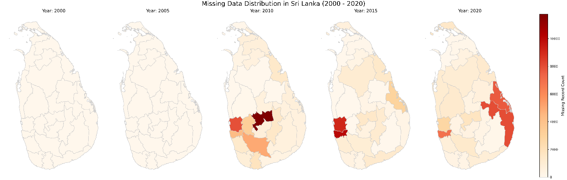
Figure 3.1 Missing record distribution across the country

Considering missing variables, each year, different variables are missing; therefore, we can find out whether it happened on purpose or randomly. In this step, any record containing at least one missing value in the selected variables is classified as a missing record.
In this study, birth order is treated as a dependent variable; therefore, the missingness of this variable can have a significant effect on advanced analysis, and particular attention is given to identifying and handling missing values in birth order. In addition, key quantitative variables named birth weight and maternal age are also examined carefully for missingness due to their importance in the analysis. Considering about high missingness in each year in 2005,2010 total missing is less than 0.1%, according to A3.1. From 2010, we get high missing percentage of variables that present more than 9%. Table 3.2 presents the high missing variables in each year. Missing records will be removed for further analysis.

3.2 Outlier Analysis
The outlier analysis process was conducted to ensure the clinical and demographic plausibility of the analytical dataset, including registered births across the study periods. By applying biologically defined limits rather than purely statistical thresholds, the study aimed to improve data reliability while preserving rare but scientifically significant health outcomes. In this study, there are only two quantitative variables, which are the Age of Mother and the Birth Weight. But in the latter part of the study, the Age of Mother works as a categorical variable,

3.2.1 Outlier analysis of Age of Mother
For the maternal age variable across the 2000–2020 study period, the valid range was strictly restricted to 10–60 years, while respecting the documented boundaries of human reproductive biology. The analysis revealed a remarkably stable maternal age distribution over the two-decade period, with the vast majority of births occurring within the standard WHO reproductive window of 15–49 years.
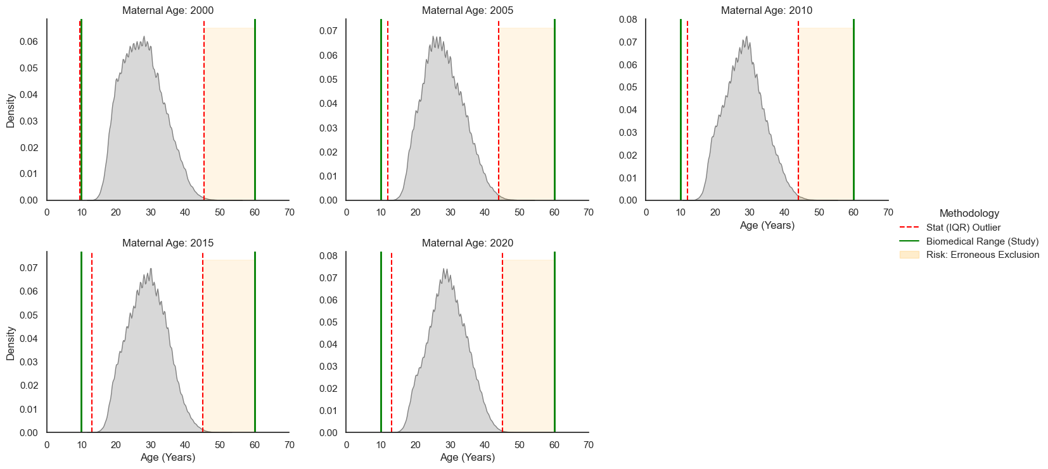
Figure 3.2 Distribution of Age of Mother From 2000 to 2020
Figure 3.2 implies that standard statistical thresholds are demographically restrictive. By overriding these mathematical bounds, the study captures the full spectrum of reproductive biology, ensuring that the clinical realities of extreme maternal age are accurately represented rather than mathematically erased.

3.2.2 Outlier analysis of Birth Weight
Regarding birth weight, which was available for the 2010, 2015, and 2020datasets, the valid range was defined as 300g to 6,000g based on the limits of clinical viability and macrosomia thresholds. Records outside this interval were considered probable data-entry errors and excluded from further analysis.
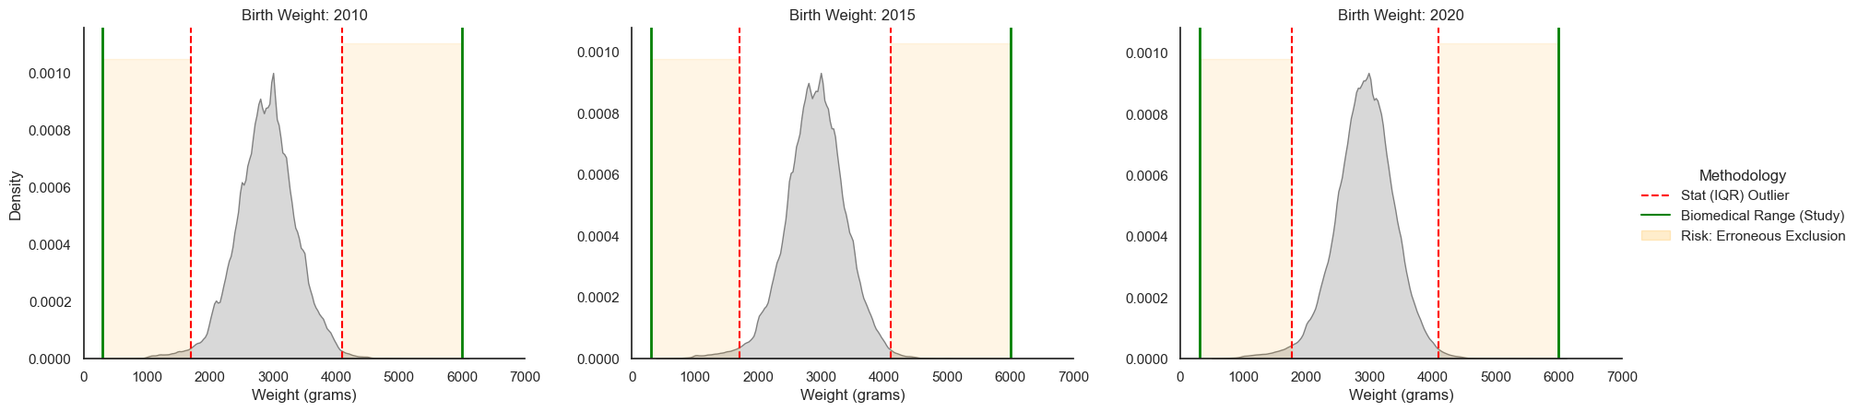
Figure 3.3 Distribution of Birth Weight From 2000 to 2020

Figure 3.3 demonstrates that statistical cleaning is clinically inappropriate for neonatal data. They imply that mathematical outliers are often clinical priorities; specifically, the most vulnerable neonates (ELBW/VLBW) must be protected from exclusion to maintain the study’s relevance to high-risk public health outcomes.

3.3 Descriptive analysis
Descriptive statistics were produced using the full analytical approach to the study population and the distribution of parity across maternal and birth-related characteristics. This section consists with few sub-sections. Figure 3.4 represents the distribution of the cleaned study data set.
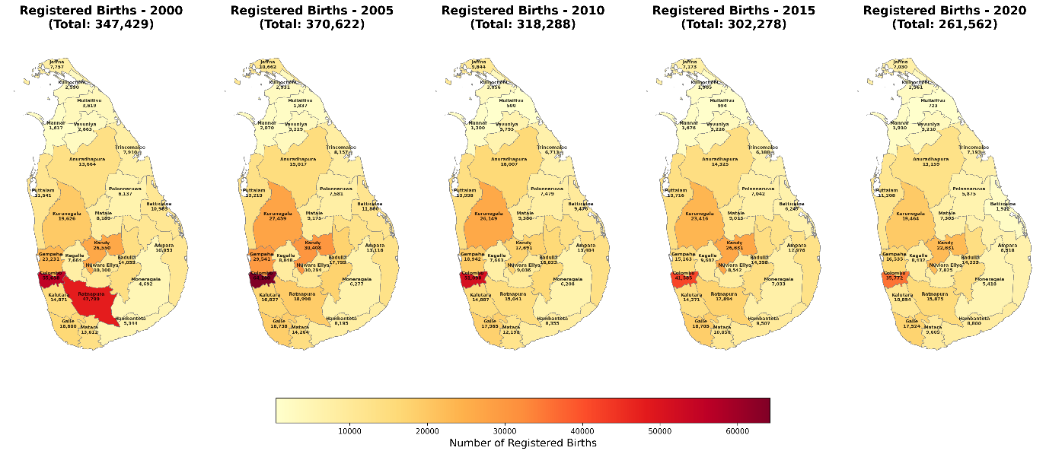
Figure 3.4 Cleaned Registered Birth Distribution across Sri Lanka in each year

3.3.1 Distribution of parity (birth order)
Birth order is the dependent variable, and the distribution of parity is distributed as Figure 3.5. This approach effectively shows how the structure of families at birth has shifted over the past 20 years.
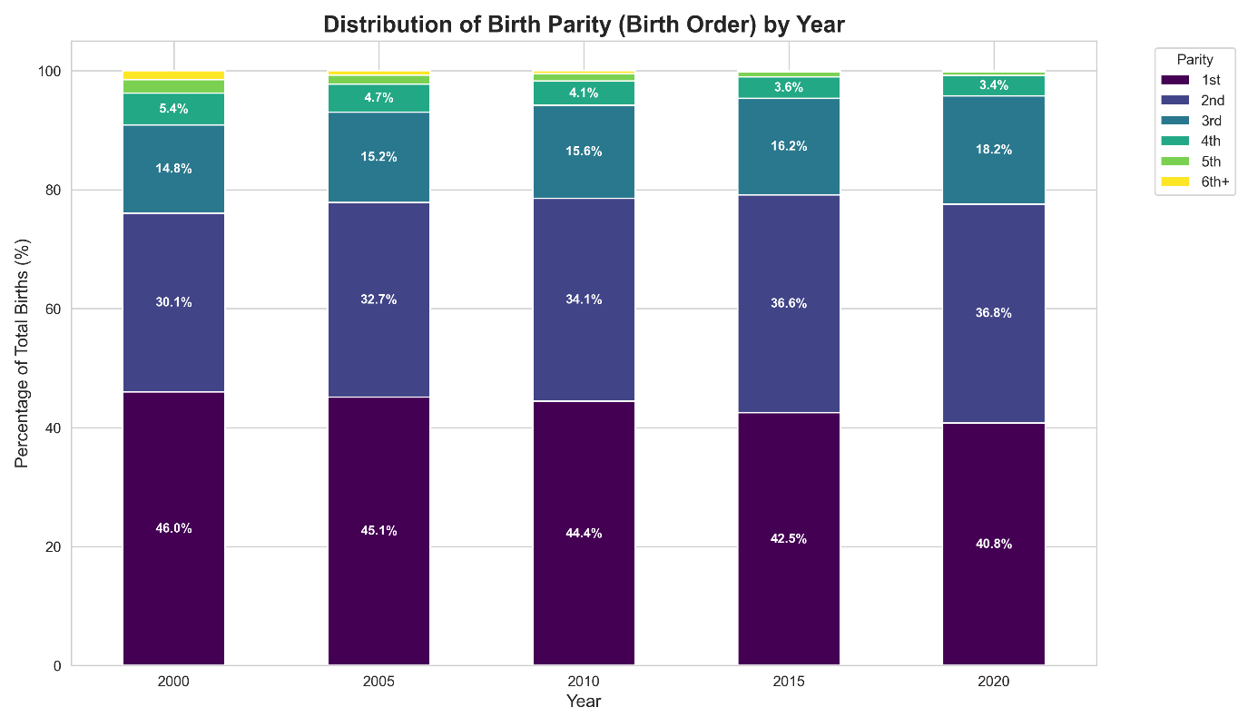 Figure 3.5 Distribution of parties in each year from 2000 to 2020
Figure 3.5 effectively demonstrates that while the total number of births may change, the internal structure of birth order remains a consistent indicator of demographic trends in Sri Lanka. Figure 3.6 presents five vertical subplots, each corresponding to a selected year (2000, 2005, 2010, 2015, and 2020), and illustrates the frequency distribution of births by parity levels ranging from first to ninth births. Across all years, the distributions exhibit a strong positive (right) skew, indicating that the highest concentration of births occurs at lower parity levels—particularly first and second births, while frequencies decline as birth order increases.
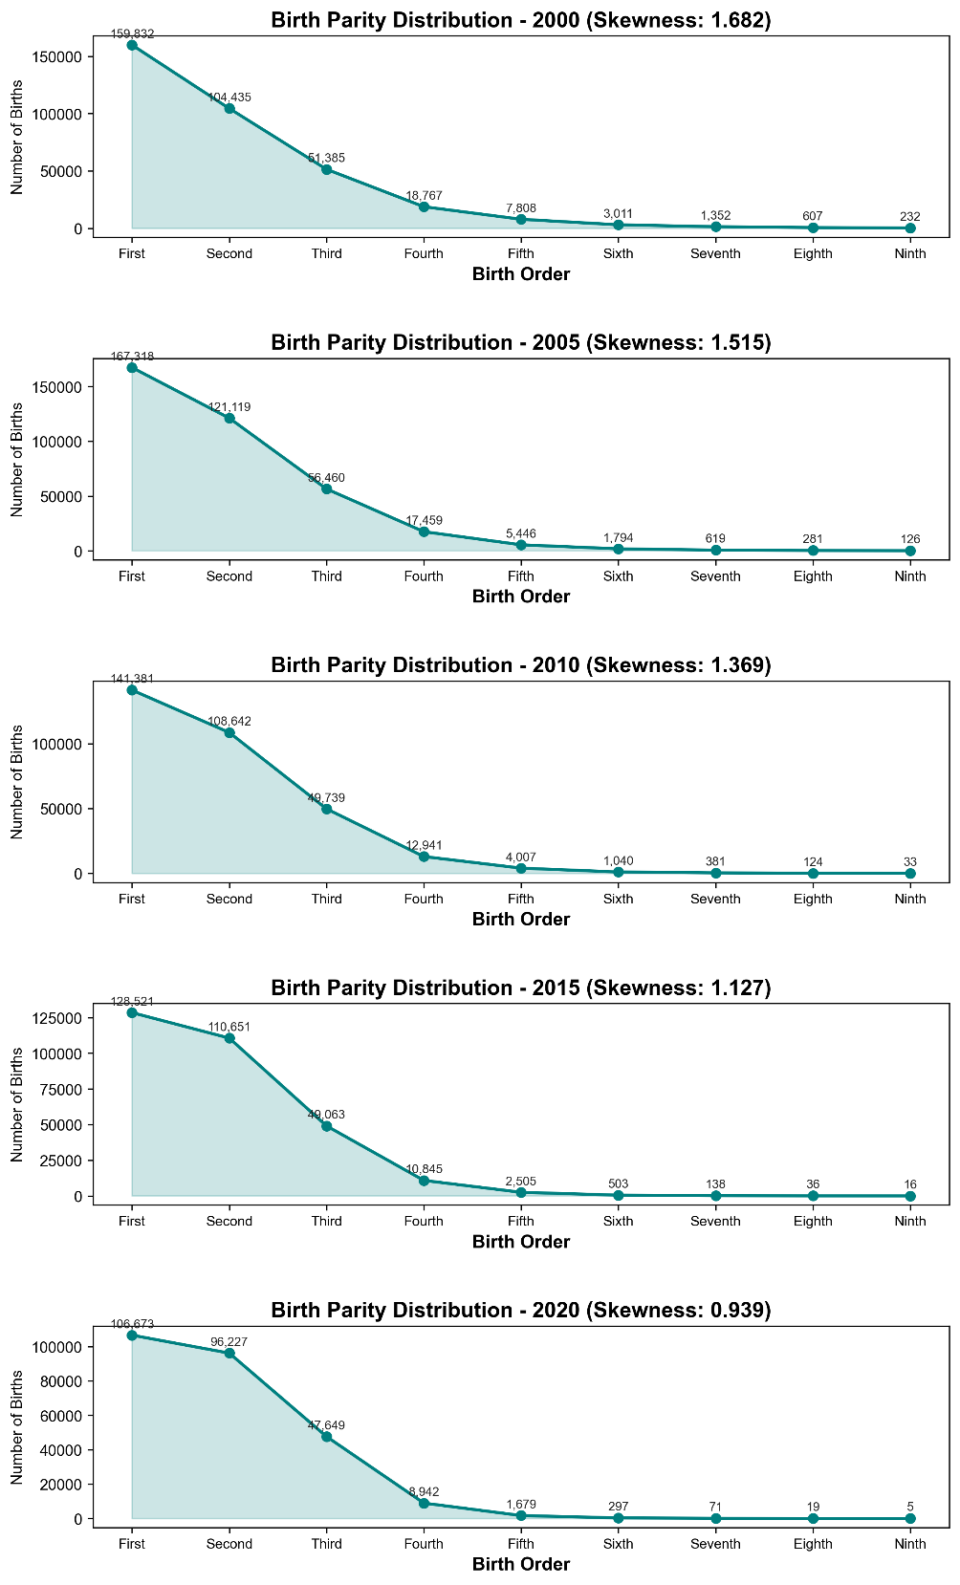
Figure 3.6 Skewness of Birth Order
With the birth, we are usually concerned about the gender of the baby because it is a socially specific thing.
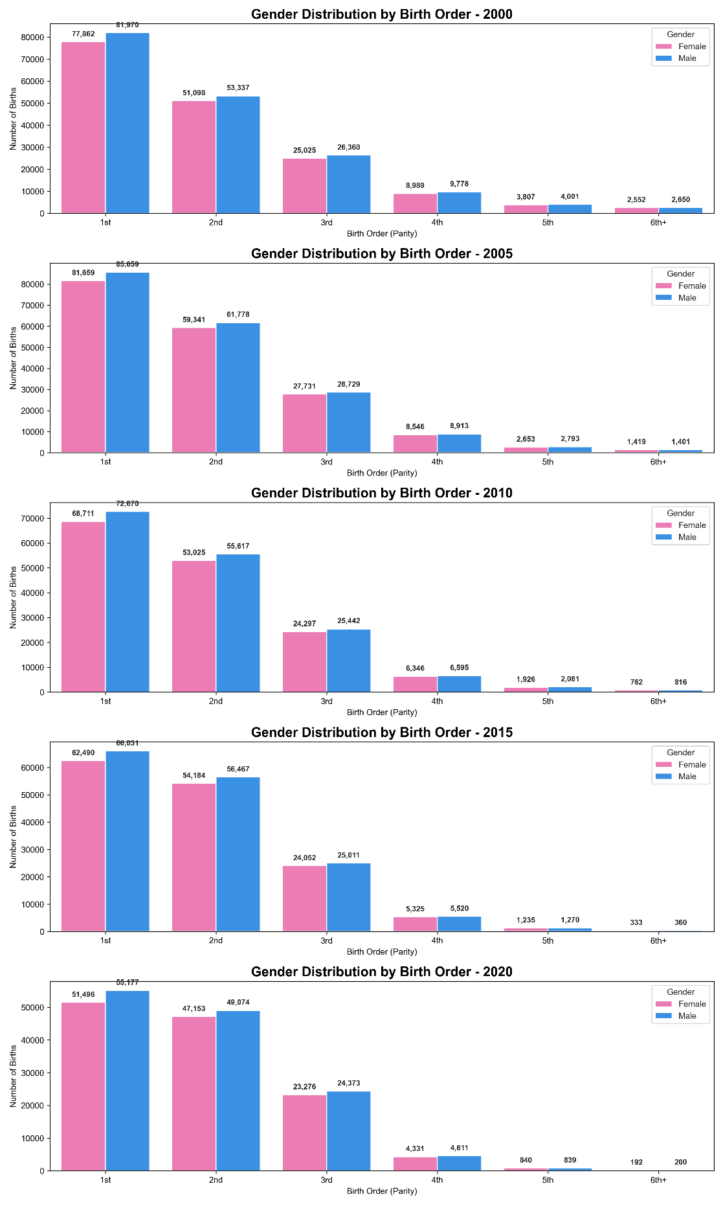
Figure 3.7 Distribution of Parity by Gender
Figure 3.7 provides several important analytical insights into birth patterns by parity and sex. First, the distribution of male and female births remains relatively balanced across all years and parity levels, indicating a stable sex ratio at birth in Sri Lanka. This suggests that the likelihood of having a male or female child does not significantly vary with increasing family size, providing no strong evidence of gender-based selection influencing parity progression. Second, the chart clearly demonstrates a sharp decline in the number of births as parity increases, with a substantial concentration at first and second births, followed by a consistent drop for third births and beyond. This pattern reflects the broader demographic transition, characterized by smaller family sizes and reduced fertility levels. Additionally, variations in the overall height of the bars across different years reveal shifts in total birth volume over time. For example, the relatively taller bars in 2010 compared to 2020 indicate that birth registrations peaked around 2010 and declined thereafter. Overall, this visualization serves as an important tool for assessing whether gender preferences play a role in shaping family size, while also confirming that the biological sex ratio remains largely consistent regardless of parity.

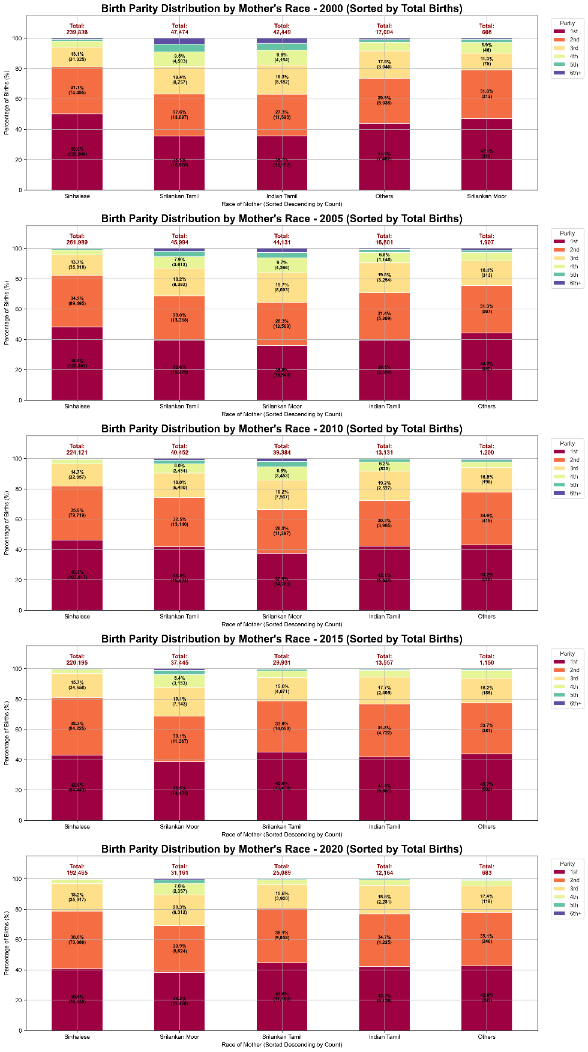
Figure 3.8 Birth Parity Distribution by Race of Mother
Figure 3.8 visualizes a comprehensive cross-sectional analysis of birth parity across major ethnic groups in Sri Lanka for the years 2000,2005,2010,2015 and 2020. The visualization highlights the dominance of the Sinhalese population in terms of birth volume. Clear differences in parity structures are observed across ethnic groups. The Sinhalese and Sri Lankan Tamil communities show a strong concentration of births at the first and second parity levels for the years 2000,2005 and 2010, then it moves to the Sinhalese and Sri Lankan Moor. In contrast, the Sri Lankan Moor community demonstrates a comparatively higher proportion of third and fourth births. Although lower-order births still dominate, the distribution shows a relatively thicker extension into higher parities, suggesting a slower transition toward low-parity fertility behavior within this group. Figure 3.7 also illustrates that across all ethnic groups, higher-order births (fourth and above) show a visible decline over time, but these times are not continuous.
To better understand regional variation in fertility behavior, this study engages in a spatial regional analytical approach that maps birth parity distribution across Sri Lanka’s administrative districts. By examining multiple discontinuous time points between 2000 and 2020, this approach captures both the temporal evolution and the spatial spread of demographic transition across the country. The use of district-level mapping is particularly useful for highlighting localized differences that may be influenced by socio-economic, cultural, and infrastructural factors.
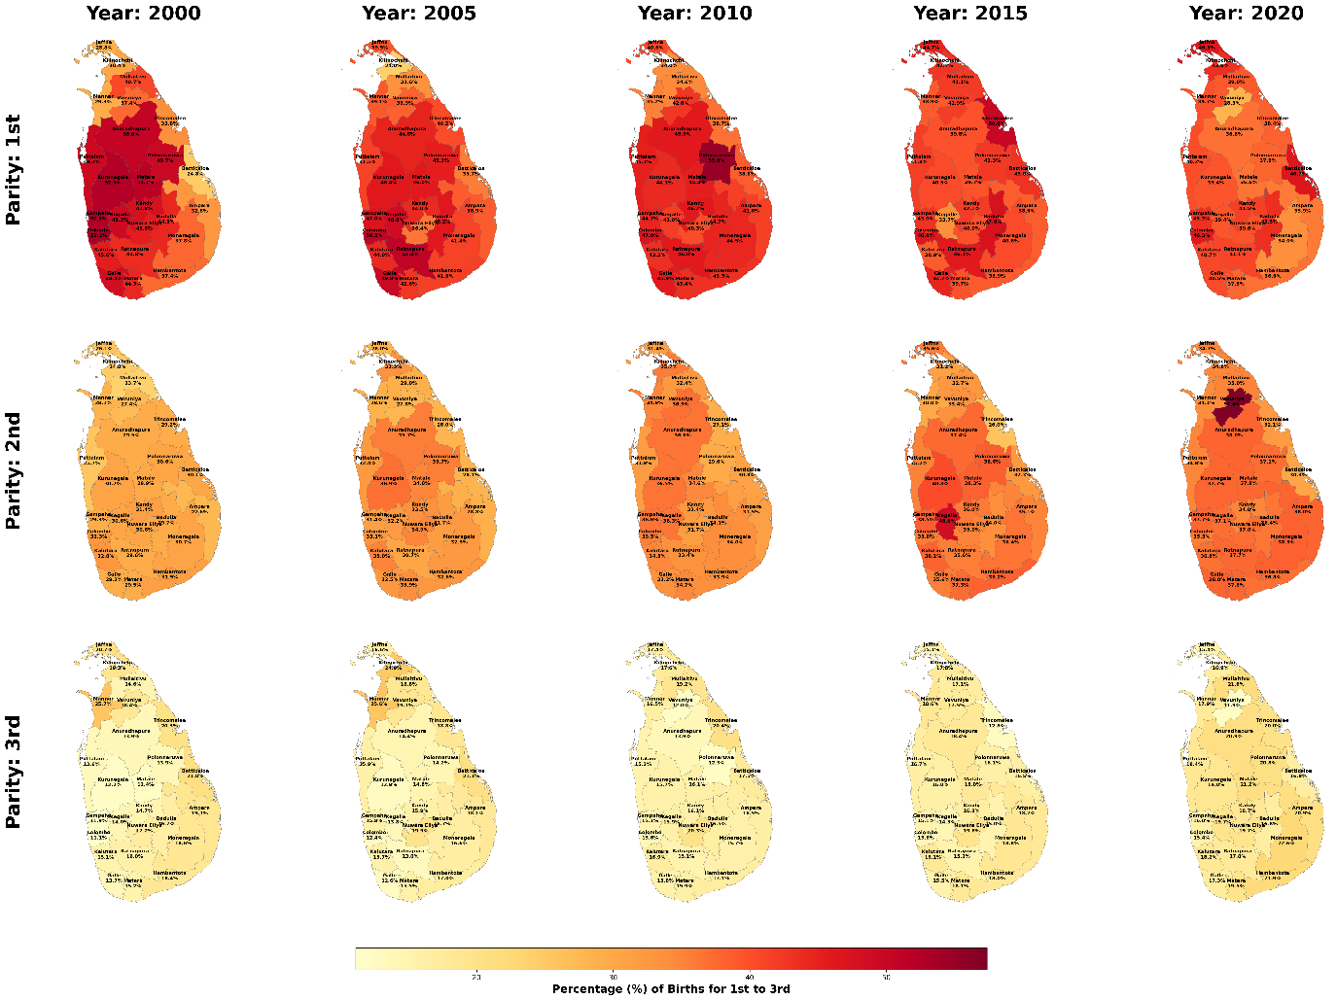
Figure 3.9 Parity across Sri Lanka (Low Order)

Figure 3.9 illustrates the spatial distribution and evolution of lower-order births across Sri Lanka. The maps show that first births are becoming more common over time, with most districts showing a clear increase. By 2020, urban districts like Colombo and Gampaha have especially high levels of first births, indicating a strong family size. Second births remain steady and common, supporting the two-child family pattern in many parts of the country.

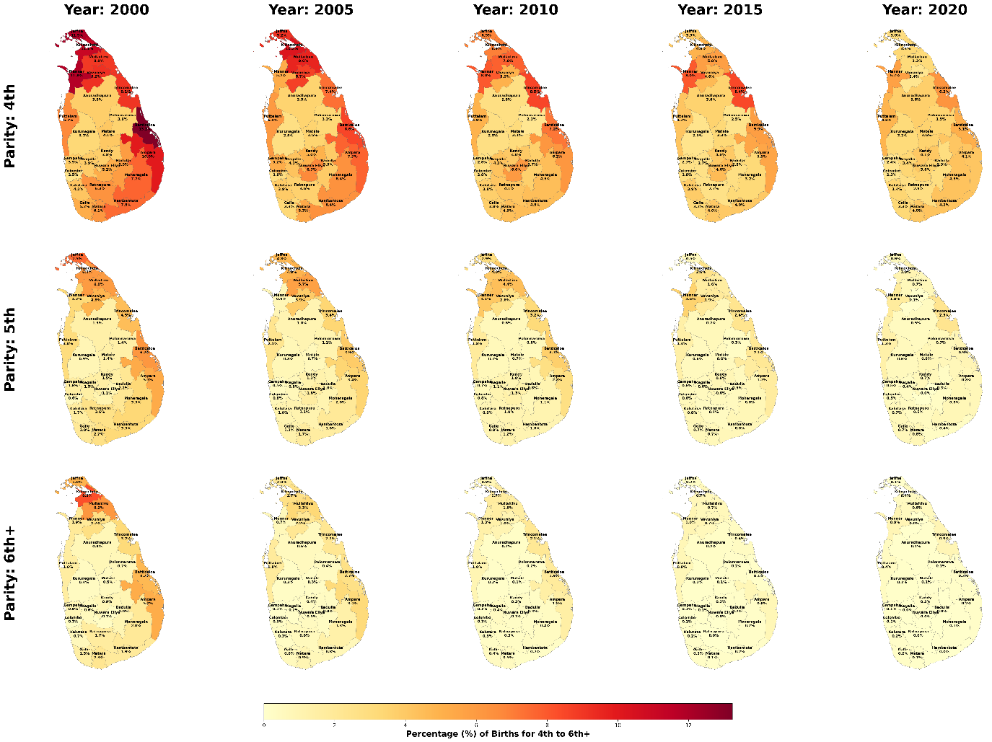
Figure 3.10 Parity across Sri Lanka (Higher Order)

Figure 3.10 captures the decline trends of higher-order births and highlights the transformation of family size structures across districts. In the early 2000s, fourth- and fifth-parity births were still present at noticeable levels, particularly in districts within the Northern and Eastern Provinces such as Ampara, Batticaloa, and Kilinochchi. These differences reflect regional social and cultural factors. However, over time, higher-order births have declined across all districts. By 2020, they are rare everywhere, with fifth and higher births making up less than one percent of total births.
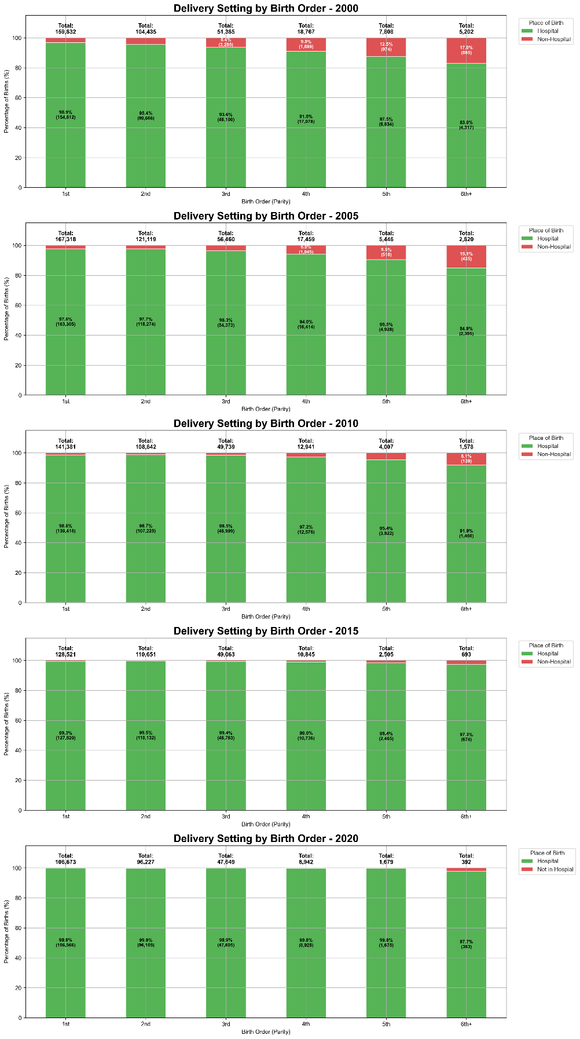
Figure 3.10 Parity Distribution by Place of Birth (Hospital or Not)
Figure 3.10 presents the relationship between birth order and place of delivery in Sri Lanka from 2000 to 2020, showing a clear shift toward nearly universal hospital births. Across all years, most deliveries occur in healthcare facilities, especially for first and second births, where hospital delivery rates consistently exceed 95 percent. In earlier years, a noticeable pattern existed in which higher-order births (fourth and above) were more likely to occur outside hospitals, possibly due to prior experience or limited access to services. However, over time, non-hospital deliveries declined across all parity levels. By 2020, hospital deliveries dominate almost entirely, even among higher-order births, indicating significant progress in maternal healthcare coverage. Although the proportion of non-hospital births is slightly higher for high-parity births, their total number is small, while lower-parity births account for a larger share of total deliveries. Overall, the figure demonstrates that Sri Lanka has achieved a near parity-neutral system, where safe, institutional delivery is accessible to mothers regardless of birth order.
As Shown in Figure 3.11, the relationship between maternal age and birth order in Sri Lanka that reveals important changes in fertility patterns over time. A key pattern shown in figure is the shift toward delayed childbirth. The peak age for first births increases from 24 years in 2000 approximately 27 years in 2020, indicating that women ae having their first child at older age. In addition to that the figure visualized lower-order births (first and second) are more concentrated within a narrow age range, while higher-order births are more widely distributed across ages, reflecting greater variability in timing among women with larger families implies that younger women are more likely to be at lower parities, while higher-order births are concentrated among older women(Bongaarts, 1982)
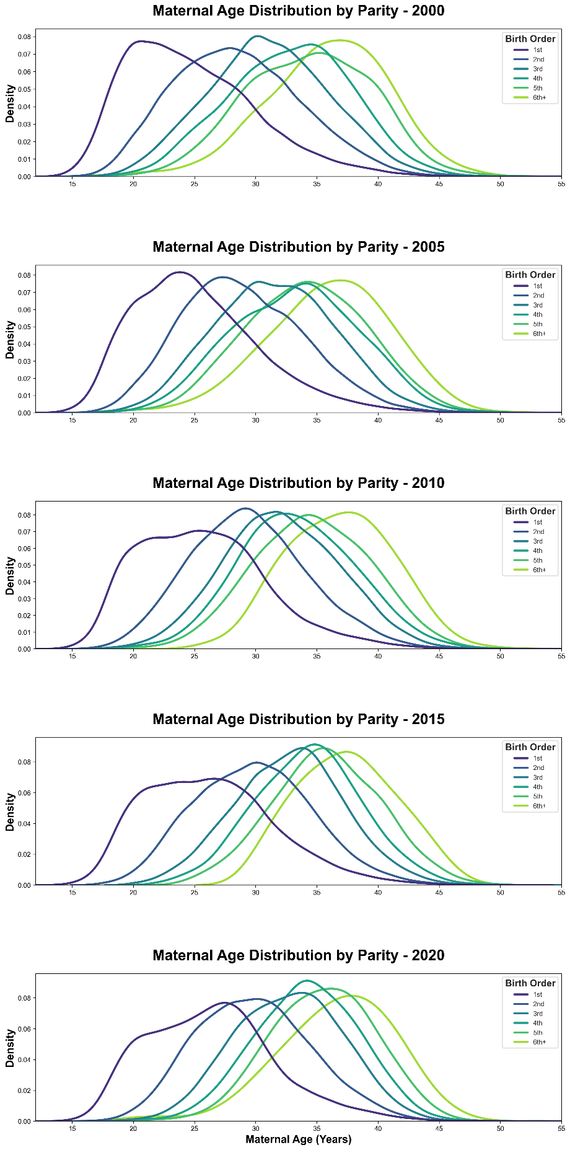
Figure 3.11 Maternal Age Distribution by Parity (2000-2020)

3.3.2 Maternal Charestics
Sri Lanka has undergone a distinct demographic transition during the first two decades of the 21st century. As illustrated in Figure 3.12, the Total Fertility Rate (TFR) experienced an incline trend from 2.22 in 2000 to a peak of 2.27 in 2005. However, the subsequent time period documented a consistent decline and reaching 1.62 children per women its implies families transform into a small scale.

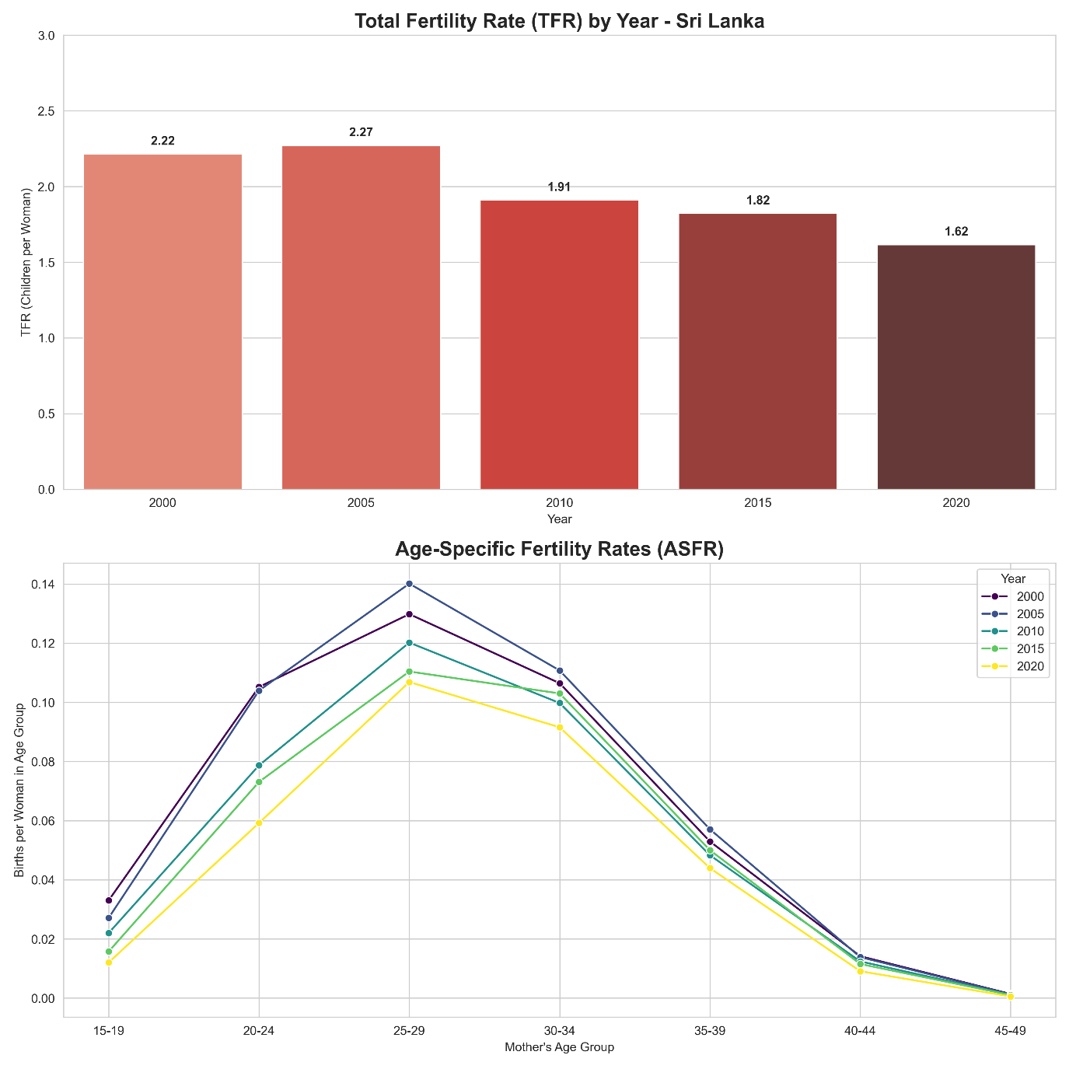Figure 3.12 Total Fertility Rate (2000-2020)
For further study, this transition breaks into subparts as Age Specific Fertility Rates (ASFR) are illustrated in Figure 3.13.

Figure 3.13 Age-Specific Fertility Rates (2000-2020)

The peak childbearing age consistently remains in the 25–29 and 30–34 age periods. However, the 2020 curve shows a significant downward shift across all age groups compared to the 2010 peak, signaling a universal reduction in fertility rather than a mere delay in childbearing.

3.4 Model Fitting
This section presents the fitted regression models used to examine the relationship between parity and the selected maternal and child-related characteristics across the study years.

3.4.1 Pre-Modelling Diagnostics
Before regression analysis, several pre-modelling diagnostic tests were conducted to assess data suitability and variable reduction through significance screening, and to ensure that the underlying assumptions of the selected models were satisfied.

3.4.1.1 Bivariate Analysis: Chi-Square Tests and Multicollinearity Assessment
Before regression modelling, chi-square tests of independence were conducted to identify the bivariate association between birth order and each categorical predictor variable. The chi-square test is widely used to assess whether a statistically significant association exists between two categorical variables (Agresti, 2018).
Null Hypothesis (H₀): Birth order is not associated with the predictor variable.
Alternative Hypothesis (H₁): Birth order is associated with the predictor variable.
A significance level of α = 0.05 was used to determine statistical significance. Variables with P-values < 0.05 were considered significantly associated with birth order and retained for subsequent multivariable regression analysis. The results of the chi-square tests for three years are represented in A3.2 to A3.4.
The chi-square tests revealed that the following variables were statistically significantly associated with birth order at the 5% significance level for all three years: age group, marital status, race of mother, Gender, and multiple birth status, and province of mother. However, having given birth at the hospital or not binary variable was only significant in the year 2020. All statistically significant variables were retained in the subsequent multivariable regression models.

3.4.1.2 Multicollinearity Assessment
Multicollinearity diagnostics were also conducted before regression modelling to evaluate the degree of linear association among independent variables. Since several predictor variables in the model contained multiple categories, multicollinearity was assessed using Generalized Variation Inflation Factor (GVIF). The results of the multicollinearity assessment are presented in Table 3.2.
Year | Values | Predictors
 |  | race_mother | province_mother | marital_status | Birth_Weight(grams) | age_group | Gender | Hospital or Not
2010 | GVIF | 2.6277 | 2.6864 | 1.0282 | 1.0277 | 1.0408 | 1.0052 | 1.0539
 | df | 11 | 8 | 1 | 1 | 4 | 1 | 1
 | GVIF ^{{1/ (2 · df)}} | 1.0449 | 1.0637 | 1.0140 | 1.0318 | 1.0050 | 1.0026 | 1.0266
2015 | GVIF | 2.2188 | 2.2318 | 1.0322 | 1.0247 | 1.0484 | 1.0056 | 1.0245
 | df | 11 | 8 | 1 | 1 | 4 | 1 | 1
 | GVIF ^{{1/ (2 · df)}} | 1.0369 | 1.0515 | 1.0160 | 1.0123 | 1.0059 | 1.0028 | 1.0122
2020 | GVIF | 2.1740 | 2.1453 | 1.0471 | 1.0220 | 1.0735 | 1.0065 | 1.0029
 | df | 5 | 8 | 1 | 1 | 4 | 1 | 1
 | GVIF ^{{1/ (2 · df)}} | 1.0807 | 1.0489 | 1.0233 | 1.0110 | 1.0089 | 1.0032 | 1.0014
Table 3.2 GVIF values of predictor variables for 2010, 2015, and 2020
According to computed GVIF values (GVIF 1/(2×df)), which were all close to 1 and well below the generally accepted threshold value of 10, indicating the absence of multicollinearity among the predictor variables included in the model. These results suggest that the independent variables were not highly correlated with one another, and therefore all selected predictors were retained for subsequent regression analyses.

3.4.2 Model 1: Ordinal Logistic Regression (Proportional Odds Model)
Ordinal logistic regression was employed to examine the relationship between birth order and selected maternal and demographic factors, where birth order was treated as an ordinal outcome variable with naturally ordered categories.

3.4.2.1 Model Fit Statistics
To evaluate the adequacy of the original logistic regression, several model fit statistics were examined, including log-likelihood, Akaike Information Criterion (AIC), Bayesian Information Criterion (BIC), pseudo- R², and model convergence status.
Table 3.3 Model Fit Statistics
Metric | Value (2010) | Value (2015) | Value (2020)
Log-Likelihood | -344634.1461 | -321209.1635 | -278391.4229
AIC | 689332.2922 | 642482.3270 | 556834.8457
BIC | 689673.7550 | 642822.1383 | 557107.1790
Pseudo-R-squared | 0.1190 | 0.1142 | 0.1140
Converged | True | True | True

As shown in Table 3.3, the ordinal logistic regression model converged successfully for all study years. The Akaike Information Criterion (AIC) and Bayesian Information Criterion (BIC) values were lowest for the 2020 model, indicating that it provided the best balance between model fit and model complexity among the three years. values ranged from 0.1140 to 0.1190, indicating that the explanatory variables accounted for approximately 11–12% of the variation in the outcome variable.

3.4.2.2 Hypothesis Testing for Model Coefficients and Creating a Significant Model Equation
To examine the relationship between birth order and the selected predictor variables, an ordinal logistic regression model was estimated. The significance of each regression coefficient was assessed using the Wald z-test at a significance level of α=0.05.
For each predictor variable, the following hypotheses were tested:
where:
- $H_{0}$: The predictor variable has no an effect on birth order.
$( H_{0}​:​β_{i}=0$)
- $H_{1}$: The predictor variable has a effect on birth order.
$(H_{1}​:​β_{i}≠0$)
Variables with $p<0.05$were considered statistically significant and interpreted as having strong evidence of association with the ordinal birth order outcome. The estimated regression coefficients and corresponding $p$-values are presented in Table 3.8.

Table 3.4 Regression Coefficients of The Ordinal Logistic Regression Model
Variable | 2010 |  |  | 2015 |  |  | 2020
 | Coeffi. | P>|z| | Signif | Coeffi. | P>|z| | Signif | Coeffi. | P>|z| | Signif
age_group_20-24 | 1.7398 | 0.0000 | *** | 1.8086 | 0.0000 | *** | 1.9589 | 0.0000 | ***
age_group_25-29 | 2.8692 | 0.0000 | *** | 2.9044 | 0.0000 | *** | 3.0700 | 0.0000 | ***
age_group_30-34 | 3.8261 | 0.0000 | *** | 3.8689 | 0.0000 | *** | 4.0705 | 0.0000 | ***
age_group_35+ | 4.5714 | 0.0000 | *** | 4.6644 | 0.0000 | *** | 4.8560 | 0.0000 | ***
marital_status_Unmarried | -0.0672 | 0.0491 | * | -0.0202 | 0.5482 |  | -0.0049 | 0.9051
race_mother_Indian Tamil | -0.0574 | 0.9210 |  | -0.1808 | 0.8113 |  | 0.0865 | 0.4578
race_mother_Malay | -0.0240 | 0.9673 |  | 0.2834 | 0.7101 |  | 0.4503 | 0.0032 | **
race_mother_Sinhalese | -0.6624 | 0.2519 |  | -0.5535 | 0.4646 |  | -0.1024 | 0.3742
race_mother_Srilankan Moor | 0.1618 | 0.7796 |  | 0.2923 | 0.6994 |  | 0.7217 | 0.0000 | ***
race_mother_Srilankan Tamil | -0.2631 | 0.6492 |  | -0.3579 | 0.6195 |  | -0.1438 | 0.2166
Gender _Male | -0.0192 | 0.0061 | ** | -0.0224 | 0.0018 | ** | -0.0373 | 0.0000 | ***
Hospital or Not_Not In Hospital | 0.0982 | 0.0014 | ** | -0.2923 | 0.0000 | *** | 0.1452 | 0.2058
province_mother_Eastern | 0.2459 | 0.0000 | *** | 0.0108 | 0.5406 |  | 0.2245 | 0.0000 | ***
province_mother_North Central | 0.0182 | 0.2270 |  | 0.2278 | 0.0000 | *** | 0.2902 | 0.0000 | ***
province_mother_North Western | 0.2109 | 0.0000 | *** | 0.2138 | 0.0000 | *** | 0.1157 | 0.0000 | ***
province_mother_Northern | 0.1826 | 0.0000 | *** | 0.0383 | 0.0945 |  | 0.0932 | 0.0001 | ***
province_mother_Sabaragamuwa | 0.0632 | 0.0000 | *** | -0.0538 | 0.0001 | *** | -0.0937 | 0.0000 | ***
province_mother_Southern | 0.0704 | 0.0000 | *** | 0.0283 | 0.0244 | * | 0.0225 | 0.0833
province_mother_Uva | 0.2356 | 0.0000 | *** | 0.0566 | 0.0001 | *** | 0.0824 | 0.0000 | ***
province_mother_Western | -0.1496 | 0.0000 | *** | -0.1643 | 0.0000 | *** | -0.3196 | 0.0000 | ***
Birth_Weight(grams) | 0.0002 | 0.0000 | *** | 0.0002 | 0.0000 | *** | 0.0003 | 0.0000 | ***
1/2 (1 vs 2+) | 2.8278 | 0.0000 | *** | 2.8947 | 0.0001 | *** | 3.6581 | 0.0000 | ***
2/3 (≤ 2 vs 3+) | 0.6314 | 0.0000 | *** | 0.6891 | 0.0000 | *** | 0.6790 | 0.0000 | ***
3/4 (≤ 3 vs 4+) | 0.5114 | 0.0000 | *** | 0.6249 | 0.0000 | *** | 0.7300 | 0.0000 | ***
4/5 (≤ 4 vs 5+) | 0.2658 | 0.0000 | *** | 0.4520 | 0.0000 | *** | 0.5626 | 0.0000 | ***
5/6 (≤ 5 vs 6+) | 0.2650 | 0.0000 | *** | 0.4415 | 0.0000 | *** | 0.5213 | 0.0000 | ***
Significance codes: *** p<0.001, ** p<0.01, * p<0.05, (blank) p≥0.05
Table 3.4 presents the estimated coefficients from the ordinal logistic regression models for 2010, 2015, and 2020, and all the fitted models are represented in A3.5. Maternal age showed a strong and consistent positive association with higher parity levels across all years. The coefficients increased steadily with maternal age, with mothers aged 35 years and above recording the highest coefficients in all three years. In 2020, the coefficient for mothers aged 35 years and above was 4.8560. This indicates that older mothers were significantly more likely to belong to higher parity categories. The magnitude of the coefficients also increased slightly over time, suggesting a strengthening relationship between maternal age and parity.
Marital status showed limited influence on parity. Unmarried mothers had a small negative and statistically significant coefficient only in 2010, while the association became statistically insignificant in 2015 and 2020. Ethnicity-related effects varied across years. Malay and Sri Lankan Moor mothers showed positive and statistically significant associations with higher parity in 2020, whereas most other ethnic categories were not statistically significant.
Provincial differences were also evident. Mothers from provinces such as Eastern, North Central, North Western, Northern, and Uva generally showed positive and significant associations with higher parity relative to the reference province, while mothers from the Western Province consistently showed negative and highly significant coefficients across all years. Negative coefficients such as -0.1496, -0.1643, and -0.3196 related to Western Province, suggesting that mothers from Western Province were less likely to belong to higher parity categories.

3.4.2.3 Odds Ratios – Ordinal Logistic Regression
The odds ratio results presented in A3.6 to A3.8 for each study year indicate the effect of each predictor variable on the likelihood of belonging to a higher parity category. Maternal age showed the strongest association with parity across all study years. Compared with the reference age group, mothers aged 35 years and above had higher odds of higher parity, with the odds increasing from 96.68 times in 2010 to 128.51 times in 2020. Similarly, mothers aged 30–34 and 25–29 years also demonstrated significantly higher odds of higher parity in all years.
Marital status showed only a weak relationship with parity. Unmarried mothers had slightly lower odds of higher parity in 2010, but the association was not statistically significant in 2015 and 2020. Ethnic differences were limited in earlier years; however, Malay and Sri Lankan Moor mothers showed significantly higher odds of higher parity in 2020 compared with the reference ethnic group. Provincial variations were also observed. Mothers from Eastern, North Central, North Western, Northern, and Uva provinces generally had higher odds of higher parity compared with the reference province. In contrast, mothers from the Western Province consistently showed lower odds of higher parity across all study years. Overall, maternal age emerged as the strongest and most consistent predictor of higher parity, while regional and ethnic differences also contributed to variations in parity patterns over time.

3.4.3 Model 2: Poisson Regression
Poisson Regression is a statistical method used to model count data and examine the relationship between a dependent count variable and one or more independent variables. It is particularly appropriate when the outcome variable represents the number of events occurring within a fixed period, area, or population, assuming the counts follow a Poisson distribution.

3.4.3.1 Dispersion Diagnostic
Before fitting count regression models, dispersion diagnostics were conducted to assess whether the parity data satisfied the equidispersion assumption required for Poisson regression. The dispersion ratio was calculated as the variance divided by the mean of the parity distribution.
Table 3.5 Dispersion Statistics for Parity Distribution
Statistic | Value  2010 | Value  2015 | Value  2020
Mean Parity | 1.8533 | 1.8438 | 1.8685
Variance Parity | 0.9562 | 0.8261 | 0.7957
Dispersion Ratio (Var/Mean) | 0.5159 | 0.4480 | 0.4259

Table 3.5 presents the dispersion statistics for the parity distribution for the years 2010, 2015, and 2020. The mean parity remained relatively stable across the study period. The dispersion ratios were 0.5159 in 2010, 0.4480 in 2015, and 0.4259 in 2020, indicating under-dispersion in the parity data. This implies that the variability in parity was lower than would be expected under a standard Poisson distribution. The decreasing dispersion ratios over time also indicate that parity levels became more concentrated around the mean during the study period. Overall, these results suggest a relatively stable and less dispersed parity distribution across the selected years.

3.4.3.2 Model Fit Statistics
Model fit statistics were examined to evaluate the adequacy of the Poisson regression model in explaining variation in parity counts.
Table 3.6 Model Fit Statistics
Metric | Value  2010 | Value  2015 | Value  2020
Log-Likelihood | -442427.5602 | -416446.8412 | -361388.0404
Deviance | 107238.1641 | 93145.8921 | 78904.7233
Null Deviance | 147406.7407 | 125223.1873 | 105225.2231
Pseudo R-squared | 0.2725 | 0.2562 | 0.2501
AIC | 884911.1204 | 832949.6824 | 722820.0808
BIC | -3925342.6091 | -3720977.8092 | -3183414.2794
Overdispersion Ratio | 0.3556 | 0.3196 | 0.3106

Table 3.6 presents the model fit statistic of the model for 2010, 2015, and 2020. The log-likelihood values improved over time, with the 2020 model showing the highest (least negative) value, indicating a comparatively better model fit.
The pseudo-$R^{2}$ values ranged from 0.2501 to 0.2725, indicating that approximately 25-27% of the variation in parity was explained by the predictor variables. The overdispersion ratios were below 1 in all years, with values ranging from 0.3106 to 0.3556. This confirms the occurrence of under-dispersion in the parity data, meaning that the variance was smaller than the mean and lower than what is typically assumed under a standard Poisson distribution. Overall, the results indicate that the Poisson regression models provided an acceptable fit to the data and captured important patterns in parity variation over the study period.

3.4.3.3 Hypothesis Testing for Model Coefficients and Creating a Significant Model Equation
The statistical significance of individual regression coefficients was evaluated using the same approach mentioned in section 3.4.2.2.
Table 3.7 Regression Coefficients and Incident Rate Ratio of Poisson Regression Model
Variable | 2010 |  |  | 2015 |  |  | 2020
 | Coeffi. | P>|z| | Signif | Coeffi. | P>|z| | Signif | Coeffi. | P>|z| | Signif
age_group_20-24 | 0.2219 | 0.0000 | *** | 0.2172 | 0.0000 | *** | 0.2246 | 0.0000 | ***
age_group_25-29 | 0.4816 | 0.0000 | *** | 0.4650 | 0.0000 | *** | 0.4761 | 0.0000 | ***
age_group_30-34 | 0.7152 | 0.0000 | *** | 0.6905 | 0.0000 | *** | 0.7042 | 0.0000 | ***
age_group_35+ | 0.8918 | 0.0000 | *** | 0.8643 | 0.0000 | *** | 0.8664 | 0.0000 | ***
marital_status_Unmarried | 0.0055 | 0.6296 |  | 0.0182 | 0.1112 |  | 0.0163 | 0.2276
race_mother_Indian Tamil | 0.0567 | 0.7812 |  | 0.0733 | 0.8080 |  | 0.0156 | 0.7200
race_mother_Malay | 0.0456 | 0.8253 |  | 0.1710 | 0.5730 |  | 0.0981 | 0.0839
race_mother_Sinhalese | -0.0995 | 0.6261 |  | -0.0178 | 0.9529 |  | -0.0303 | 0.4808
race_mother_Srilankan Moor | 0.1121 | 0.5830 |  | 0.1858 | 0.5378 |  | 0.1616 | 0.0002 | ***
race_mother_Srilankan Tamil | 0.0097 | 0.9619 |  | 0.0302 | 0.9202 |  | -0.0322 | 0.4582
Gender _Male | -0.0031 | 0.2386 |  | -0.0041 | 0.1252 |  | -0.0071 | 0.0136 | *
Hospital or Not_Not In Hospita | 0.0324 | 0.0016 | ** | -0.0454 | 0.0078 | ** | 0.0716 | 0.0753
province_mother_Eastern | 0.0651 | 0.0000 | *** | 0.0095 | 0.1090 |  | 0.0470 | 0.0000 | ***
province_mother_North Central | 0.0051 | 0.3712 |  | 0.0479 | 0.0000 | *** | 0.0594 | 0.0000 | ***
province_mother_North Western | 0.0580 | 0.0000 | *** | 0.0544 | 0.0000 | *** | 0.0289 | 0.0001 | ***
province_mother_Northern | 0.0495 | 0.0000 | *** | 0.0189 | 0.0235 | * | 0.0143 | 0.0963
province_mother_Sabaragamuwa | 0.0220 | 0.0001 | *** | -0.0137 | 0.0086 | ** | -0.0201 | 0.0002 | ***
province_mother_Southern | 0.0270 | 0.0000 | *** | 0.0134 | 0.0046 | ** | 0.0089 | 0.0685
province_mother_Uva | 0.0575 | 0.0000 | *** | 0.0154 | 0.0058 | ** | 0.0155 | 0.0077 | **
province_mother_Western | -0.0318 | 0.0000 | *** | -0.0306 | 0.0000 | *** | -0.0648 | 0.0000 | ***
Birth_Weight(grams) | 0.000001 | 0.0000 | *** | 0.000001 | 0.0000 | *** | 0.0001 | 0.0000 | ***
Intercept $β_{0}$ | -0.0132 | 0.9485 |  | -0.0712 | 0.8134 |  | -0.0992 | 0.0272 | *
Significance codes: *** p<0.001, ** p<0.01, * p<0.05, (blank) p≥0.05
The Poisson regression coefficients presented in Table 3.7 and fitted models showed in A3.9 indicate the relationship between parity and the predictor variable across the years 2010, 2015, and 2020. Here also Maternal age showed a strong and consistent positive association with parity across all years. The coefficients increased progressively with maternal age, indicating that older mothers were more likely to have higher parity levels. Mothers aged 35 years and above recorded the largest coefficients throughout the study period. For example, in 2020, the coefficient for mothers aged 35 years and above was 0.8664, indicating that mothers in this category had a higher expected parity count. Most ethnic categories were not statistically significant.
Provincial variations were observed across the study period. Mothers from Eastern, North Western, North Central, and Uva provinces generally had higher parity levels than the reference province, while mothers from the Western Province consistently showed significantly negative values in all years, indicating a comparatively lower parity level. Sabaragamuwa Province showed negative coefficients in 2015 and 2020, indicating lower parity levels during these years. Overall, maternal age remained the strongest and most consistent predictor of parity, while regional differences also contributed notably to parity variation over time.

3.4.3.4 Incidence Rate Ratio
Incidence Rate Ratios (IRRs) were obtained by exponentiating the estimated Poisson regression coefficients. IRRs represent the multiplicative effect of each predictor on the expected parity count. An IRR greater than 1 indicates increased expected parity count, whereas an IRR less than 1 indicates decreased expected parity count.
A3.10 to A3.112 present the IRR obtained from the Poisson regression model. The results indicate that maternal age was the strongest predictor of parity across all study years. Mothers aged 35 years and above had approximately 2.4 times higher expected parity levels in all years, while mothers aged 30–34 years had about twice the expected parity. Similarly, mothers aged 25–29 years and 20–24 years also showed significantly higher expected parity levels relative to the reference category. Provincial differences were also observed in the models. Overall, the IRR results confirm that maternal age remained the most influential determinant of parity throughout the study period, while regional and ethnic differences also contributed to variations in parity patterns in Sri Lanka.

3.4.4 Model 3: Binary Logistic Regression
Binary Logistic Regression is a statistical technique used to examine the relationship between a binary dependent variable and one or more independent variables. It estimates the probability of an event occurring by modelling the log odds of the outcome as a function of the predictor variables.

3.4.4.1 Model Fit Statistics
To evaluate the adequacy and overall performance of the binary logistic regression model, several model fit statistics were examined. These statistics assess whether the inclusion of explanatory variables significantly improves the prediction of first-born versus later-born births compared to the null model. Measures such as the likelihood ratio test, pseudo $R^{2},$AIC and BIC were used to assess the fitted model stored in Table 3.8.
Table 3.8 Model Fit Statistics
Metric | Value  2010 | Value  2015 | Value  2020
Log-Likelihood (Full Model) | -183603.1899 | -175786.6301 | -150487.4392
Log-Likelihood (Null Model) | -218633.6594 | -206125.6041 | -176817.1285
Likelihood Ratio (LR) Statistic | 70060.9389 | 60677.9479 | 52659.3786
LR Test P-value | 0.000000 | 0.000000 | 0.000000
Pseudo R-squared (McFadden) | 0.1602 | 0.1472 | 0.1489
AIC | 367262.38 | 351629.26 | 301018.88
BIC | 367561.16 | 351926.60 | 301249.31

Table 3.8 presents the model fit statistics for the binary logistic regression models estimated for 2010,2015, and 2020. The AIC and BIC values decreased from 2010 to 2020, suggesting an improvement in model fit and efficiency over time. Among the three models, the 2020 model recorded the lowest AIC and BIC values, indicating comparatively better performance. Overall, the results suggest that the binary logistic regression models provided an adequate fit to the data and that the selected explanatory variables were important predictors of parity outcomes across the study period.

3.4.4.2 Hypothesis Testing for Model Coefficients and Creating a Significant Model Equation
The statistical significance of individual regression coefficients was evaluated using the same approach mentioned in section 3.4.2.2.
Table 3.9 Regression Coefficients of The Binary Logistic Regression Model
Variable | 2010 |  |  | 2015 |  |  | 2020
 | Coeffi. | P>|z| | Sig. | Coeffi. | P>|z| | Sig | Coeffi. | P>|z| | Sig
age_group_20-24 | -1.7167 | 0.0000 | *** | -1.8043 | 0.0000 | *** | -1.9603 | 0.0000 | ***
age_group_25-29 | -2.7981 | 0.0000 | *** | -2.8490 | 0.0000 | *** | -3.0082 | 0.0000 | ***
age_group_30-34 | -3.6982 | 0.0000 | *** | -3.7473 | 0.0000 | *** | -3.9516 | 0.0000 | ***
age_group_35+ | -4.2338 | 0.0000 | *** | -4.2783 | 0.0000 | *** | -4.5143 | 0.0000 | ***
marital_status_Unmarried | 0.2068 | 0.0000 | *** | 0.1250 | 0.0007 | *** | 0.2022 | 0.0000 | ***
race_mother_Indian Tamil | 0.3563 | 0.5404 |  | -0.6238 | 0.4660 |  | -0.0839 | 0.5190
race_mother_Malay | 0.1236 | 0.8345 |  | -0.9628 | 0.2643 |  | -0.3864 | 0.0246 | *
race_mother_Sinhalese | 0.7400 | 0.2033 |  | -0.3871 | 0.6510 |  | 0.0319 | 0.8038
race_mother_Srilankan Moor | 0.2503 | 0.6670 |  | -0.8724 | 0.3079 |  | -0.4722 | 0.0003 | ***
race_mother_Srilankan Tamil | 0.4989 | 0.3912 |  | -0.4640 | 0.5877 |  | 0.1715 | 0.1865
Gender _Male | 0.0234 | 0.0035 | ** | 0.0267 | 0.0011 | ** | 0.0465 | 0.0000 | ***
Hospital or Not_Not In Hospital | -0.0057 | 0.8726 |  | 0.3658 | 0.0000 | *** | -0.2522 | 0.0718
province_mother_Eastern | -0.1852 | 0.0000 | *** | 0.0424 | 0.0221 | * | -0.2133 | 0.0000 | ***
province_mother_North Central | -0.0040 | 0.8144 |  | -0.2055 | 0.0000 | *** | -0.2875 | 0.0000 | ***
province_mother_North Western | -0.1289 | 0.0000 | *** | -0.1759 | 0.0000 | *** | -0.0935 | 0.0001 | ***
province_mother_Northern | -0.1543 | 0.0000 | *** | 0.0303 | 0.2398 |  | -0.2250 | 0.0000 | ***
province_mother_Sabaragamuwa | -0.0296 | 0.0825 |  | -0.0034 | 0.8279 |  | 0.0730 | 0.0000 | ***
province_mother_Southern | -0.0039 | 0.7931 |  | 0.0279 | 0.0532 |  | -0.0030 | 0.8416
province_mother_Uva | -0.2031 | 0.0000 | *** | 0.0229 | 0.1701 |  | -0.0528 | 0.0032 | **
province_mother_Western | 0.1299 | 0.0000 | *** | 0.1630 | 0.0000 | *** | 0.2931 | 0.0000 | ***
Birth_Weight(grams) | -0.0002 | 0.0000 | *** | -0.0002 | 0.0000 | *** | -0.0003 | 0.0000 | ***
Intercept $β_{0}$ | 2.7076 | 0.0000 | *** | 3.7768 | 0.0000 | *** | 3.6209 | 0.0000 | ***
Significance codes: *** p<0.001, ** p<0.01, * p<0.05, (blank) p≥0.05
The estimated coefficients from the binary logistic regression models for 2010, 2015, and 2020 are presented in Table 3.9, and the fitted models are presented in A3.13. In these models, maternal age showed a strong and statistically significant negative association with the binary parity outcome across all study years. Same as other models in 2020, mothers aged 35 and above had a coefficient of -4.5143 implies that births to older mothers were substantially less likely to be first-born births and more likely to belong to later birth orders. Similarly, the positive coefficients for marital status, 0.2068, 0.1250, and 0.2022in each year indicate that unmarried mothers had relatively higher odds of first-born births. Marital status showed a positive and statistically significant relationship across the study period. Ethnic effects varied across years, although Malay and Sri Lankan Moor mothers demonstrated significant negative associations in 2020. Most other ethnic categories were not statistically significant. Overall, maternal age continued to be the most influential predictor in the binary logistic regression models, while regional variation and selected demographic characteristics also contributed to differences in parity outcomes over time.

3.4.4.3 Odds Ratios
Odds Ratios (OR) are derived by exponentiating the coefficients from the binary logistic regression model. They represent the multiplicative effect on the odds of being first-born versus later-born.
Interpretation guidelines:
• OR = 1.00: No effect on the odds of being first-born
• OR > 1.00: Associated with HIGHER odds of being first-born
• OR < 1.00: Associated with LOWER odds of being first-born (higher odds of being later-born)
For a one-unit increase in the predictor, the odds of being first-born are multiplied by the OR.
A3.14 to A3.16 present the odds ratios from the binary logistic regression models. Maternal age showed the strongest and most consistent association with birth order across all study years. The odds ratios decreased progressively with maternal age, with mothers aged 35 years and above showing the lowest odds of first-born births in all years. Ethnic differences were generally limited, although Malay and Sri Lankan Moor mothers in 2020 showed significantly lower odds of first-born births, suggesting relatively higher probabilities of later-born births in these groups. Regional variation was also evident. Mothers from Eastern, North Central, North Western, Northern, and Uva provinces generally showed lower odds of first-born births compared with the reference province, indicating relatively higher proportions of later-born births in these regions. Overall, the binary logistic regression results indicate that maternal age was the most influential determinant distinguishing first-born from later-born births, while regional and selected demographic characteristics also contributed to differences in birth order patterns over time.

3.4.5 Model Comparison and Summary
This section compares the three modeling approaches used to analyze parity data.
Comparison criteria include AIC, BIC, and Log-Likelihood. Lower AIC/BIC values indicate a better fit, while higher Log-Likelihood indicates a better fit.
Table 3.10: Summary Comparison of the Three Regression Models
Model | Outcome | Effect measure | Year | AIC | BIC | Log-Likelihood
Ordinal Logistic (POM) | Birth order 1-9 (ordered) | Cumulative OR | 2010 | 689332.29 | 689673.75 | -344634.15
 |  |  | 2015 | 642482.33 | 642822.14 | -321209.16
 |  |  | 2020 | 556834.85 | 557107.18 | -278391.42
Poisson Regression | Birth order 1-9 (count) | IRR | 2010 | 884911.12 | -3925342.61 | -442427.56
 |  |  | 2015 | 832949.68 | -3720977.81 | -416446.84
 |  |  | 2020 | 722820.08 | -3183414.28 | -361388.04
Binary Logistic | Parity 1 vs  ≥ 2 (binary) | OR | 2010 | 367262.38 | 367561.16 | -183603.19
 |  |  | 2015 | 351629.26 | 351926.6 | -175786.63
 |  |  | 2020 | 301018.88 | 301249.31 | -150487.44

Table 3.10 presents a comparison of the three regression modelling approaches used to analyze parity patterns across the study years 2010, 2015, and 2020. Across all three modelling approaches, the model fit statistics improved over time, with lower AIC values and higher log-likelihood values observed in 2020 compared with 2010. Among the three models, the binary logistic regression model consistently produced the lowest AIC values, indicating comparatively better model fit and efficiency for distinguishing between first-born and later-born births. Overall, each of the regression modelling approaches gives a view of parity patterns in Sri Lanka. The ordinal logistic regression model is good for looking at parity categories that are in order. The Poisson regression model is useful when we want to count parity levels. The binary logistic regression model is the way to distinguish between first-born and later-born births. It is simple. It fits the data very well. The binary logistic regression model is the one for this.

4 Conclusion
This chapter presents the conclusions drawn from the analysis of parity and associated maternal and birth-related characteristics in Sri Lanka, using the civil registration birth data from the Registrar General’s Department for the years 2000, 2005, 2010, 2015, and 2020.

4.1 Summary of Key Findings
The study design focuses on distinguishing first-born from later-born children and investigates how parity distributions and associated factors changed across selected years. The findings are summarized below in relation to each specific objective.

4.1.1 Distribution and Characteristics of First-Born and Later-Born Children
The descriptive analysis shows that Sri Lanka’s birth order distribution is heavily concentrated at low parities, with first and second births consistently. In the study period, higher-order (fourth and above) had become rare across all administrative districts. The male and female births showed no meaningful variation by birth order, providing no evidence of a preference for a specific gender that influences parity progression in Sri Lanka. The place of delivery showed a strong and increasing shift toward institutional births. Multiple births constituted a small but stable proportion of all registered births.

4.1.2 Maternal Characteristics Associated with Parity
The analysis of maternal characteristics revealed several important characteristics and temporal shifts. The Total Fertility Rate (TFR) declined from 2.27 in 2005 to 1.62 in 2020, confirming that Sri Lanka has transitioned to a low replacement level of fertility. The peak age for first births increased from approximately 24 years in 2000 to 27 years in 2020, reflecting delayed entry into parenthood. Maternal age appeared as the most important factor associated with parity across all analytical approaches used in the study. Older mothers were more likely to be at higher parities, while younger mothers were concentrated at lower parities. Marital status showed a limited and inconsistent association with parity across the study period. Regional differences in parity patterns also occurred. Mothers from the Western Province consistently showed lower parity levels compared with mothers from other provinces, while mothers from the Eastern, North Central, North Western, and Uva provinces show higher parity levels. This reflects differences in urbanization, quality of education, and cultural attitudes towards family size.

4.1.3 Regression Modelling and Factors Independently Associated with Parity
Three regression modelling approaches were used to identify factors independently associated with parity. Ordinal logistic regression (proportional odds model), Poisson regression, and binary logistic regression are the models used. The models were fitted using data from 2010, 2015, and 2020. Across all three models and all three years, maternal age was the strongest and most consistent predictor. The child’s sex and Birth weight also show a significant association with parity in several models and years. Model comparison was done by using AIC, BIC, and log-likelihood values, which indicated that the binary logistic regression model provided the best-fitted model from all three approaches. However, the three models are not directly comparable because they operationalize the outcome variable differently.

4.2 Limitations of the Study
Several limitations have to be discussed in this study. The CRVS data do not include some important socioeconomic variables, such as maternal education, employment status, and income, which are identified as the determinants of fertility behavior. The occurrence of the missing data created a challenge, particularly for the years 2010,2015, and 2020, where missingness in birth weight and birth order variables exceed 10% in some cases. The regression modelling was limited to the years 2010,2015, and 2020 due to data availability. However, the models still provide useful estimates.

4.3 Recommendations for Future Research

Based on the key findings and limitations of the study, several directions for future research can be identified. Combined viral statistics records with other administrative datasets, such as education records or health-related data, could help to advance studies. Spatial analysis can be conducted in future studies with advanced geographic levels, such as divisional secretariat divisions, which could reveal localized fertility patterns. Future studies could also explore the application of alternative statistical models, and advanced ethnicity analysis can also be conducted. Finally, as Sri Lanka transitions to a fully digital CRVS platform, future research should evaluate the impact of digitalization on data quality, completeness, and timeliness, and explore how real-time birth registration data could be used for continuous monitoring of fertility patterns and maternal health indicators.

4.4 Chapter Summary
This study has provided a comprehensive analysis of parity patterns and their associated maternal and birth-related characteristics in Sri Lanka over the first two decades of the twenty-first century. Using population-level civil registration data, the study documented the continued concentration of births at lower parities, the rising age at first birth, the decline of the Total Fertility Rate below replacement level, and significant regional and ethnic variations in parity distributions. The regression modelling confirmed maternal age as the dominant predictor of parity across all modelling approaches, with regional and ethnic factors also contributing to parity variation.
The findings demonstrated the analytical potential of Sri Lanka’s CRVS system as a resource for population research. These findings also help to update healthcare facilities and inform population policy in the context.

References
Abeywickrama, G., S Padmadas, S., & Hinde, A. (2020). Social inequalities in low birthweight outcomes in Sri Lanka: evidence from the Demographic and Health Survey 2016. BMJ Open, 10(5), e037223. https://doi.org/10.1136/bmjopen-2020-037223
Adeleke. (2010). Ordinal Logistic Regression Model: An Application to Pregnancy Outcomes. Journal of Mathematics and Statistics, 6(3), 279–285. https://doi.org/10.3844/jmssp.2010.279.285
Agresti, Alan. (2018). Statistical methods for the social sciences. Pearson.
Alcock, S., Leal, M., Beukes, J., Nyati, L. H., Thompson, U., & Norris, S. A. (2025). Maternal age and parity influences on health outcomes: a multivariable regression analysis of mothers and infants. BMC Pregnancy and Childbirth, 25(1), 1094. https://doi.org/10.1186/s12884-025-08194-8
Belbasis, L., Savvidou, M. D., Kanu, C., Evangelou, E., & Tzoulaki, I. (2016). Birth weight in relation to health and disease in later life: an umbrella review of systematic reviews and meta-analyses. BMC Medicine, 14(1), 147–162. https://doi.org/10.1186/s12916-016-0692-5
Births and Deaths Registration Act, No. 17 of 1951 (as Amended). Government of Sri Lanka. (1951). https://www.srilankalaw.lk/b/96-births-and-deaths-registration-act.html
Blencowe, H., Krasevec, J., de Onis, M., Black, R. E., An, X., Stevens, G. A., Borghi, E., Hayashi, C., Estevez, D., Cegolon, L., Shiekh, S., Ponce Hardy, V., Lawn, J. E., & Cousens, S. (2019). National, regional, and worldwide estimates of low birthweight in 2015, with trends from 2000: a systematic analysis. The Lancet Global Health, 7(7), 849–860. https://doi.org/10.1016/S2214-109X(18)30565-5
Bongaarts, J. (1978). A Framework for Analyzing the Proximate Determinants of Fertility. Population and Development Review, 4(1), 105–132. https://doi.org/10.2307/1972149
Bongaarts, J. (1982). The Fertility-Inhibiting Effects of the Intermediate Fertility Variables. Studies in Family Planning, 13(6/7), 179–189. https://doi.org/10.2307/1965445
Bongaarts, J. (1998). Fertility and reproductive preferences in post-transitional societies. https://doi.org/10.31899/pgy6.1015
Bongaarts, J. (2002). THE END OF THE FERTILITY TRANSITION IN THE DEVELOPING WORLD.
Bongaarts, J. (2025). Fertility Transitions in Low‐ and Middle‐Income Countries: The Role of Preferences. Population and Development Review, 51(1), 163–180. https://doi.org/10.1111/padr.12675
Brzozowska, Z., Beaujouan, E., & Zeman, K. (2022). Is Two Still Best? Change in Parity-Specific Fertility Across Education in Low-Fertility Countries. Population Research and Policy Review, 41(5), 2085–2114. https://doi.org/10.1007/s11113-022-09716-4
Caldwell, J. C. (1986). Routes to Low Mortality in Poor Countries. Population and Development Review, 12(2), 171. https://doi.org/10.2307/1973108
Cleland, J. (2002). EDUCATION AND FUTURE FERTILITY TRENDS, WITH SPECIAL REFERENCE TO MID-TRANSITIONAL COUNTRIES. https://www.un.org/development/desa/pd/sites/www.un.org.development.desa.pd/files/unpd_egm_200203_backgroundpaper_education_and_future_fertility_trends_cleland.pdf
Das, S., & Rahman, R. M. (2011). Application of ordinal logistic regression analysis in determining risk factors of child malnutrition in Bangladesh. Nutrition Journal, 10(1), 124. https://doi.org/10.1186/1475-2891-10-124
De Silva, R., & De Silva, W. I. (2025). Sri Lanka is on the Verge of Entering Ultra-Low Fertility: Estimating Total Fertility Rate Through an Alternative Method Validation with South Korea. In ReproSex: International Journal on Sexual and Reproductive Health (Vol. 1, Number 1).
Department of Census & Statistics. (2025). Vital Statistics. https://www.statistics.gov.lk/Population/StaticalInformation/VitalStatistics
Department of Census and Statistics. (2017). Sri Lanka : Demographic and Health Survey 2016. Department of Census and Statistics, Ministry of National Policies and Economic Affairs : Health Sector Development Project, Ministry of Health, Nutrition and Indigenous Medicine. https://www.statistics.gov.lk/Resource/en/Health/DemographicAndHealthSurveyReport-2016-Contents.pdf
Fox, J., & Monette, G. (1992). Generalized Collinearity Diagnostics. Journal of the American Statistical Association, 87(417), 178–183. https://doi.org/10.1080/01621459.1992.10475190
Frejka, T., & Sardon, J.-P. (2007). Cohort birth order, parity progression ratio and parity distribution trends in developed countries. Demographic Research, 16, 315–374. https://doi.org/10.4054/DemRes.2007.16.11
Guilmoto, C. Z. (2009). The Sex Ratio Transition in Asia. Population and Development Review, 35(3), 519–549. https://doi.org/10.1111/j.1728-4457.2009.00295.x
Hayashi, C., Mikami, H., Nishihara, R., Maeda, C., & Hayakawa, K. (2014). The Relationship Between Twin Language, Twins’ Close Ties, and Social Competence. Twin Research and Human Genetics, 17(1), 27–37. https://doi.org/10.1017/thg.2013.83
Hosmer, D. W., Lemeshow, Stanley., & Sturdivant, R. X. (2013). Applied logistic regression. Wiley.
Hughes, M. M., Black, R. E., & Katz, J. (2017a). 2500-g Low Birth Weight Cutoff: History and Implications for Future Research and Policy. Maternal and Child Health Journal, 21(2), 283–289. https://doi.org/10.1007/s10995-016-2131-9
Hughes, M. M., Black, R. E., & Katz, J. (2017b). 2500-g Low Birth Weight Cutoff: History and Implications for Future Research and Policy. Maternal and Child Health Journal, 21(2), 283–289. https://doi.org/10.1007/s10995-016-2131-9
Jayachandran, S., & Pande, R. (2017). Why Are Indian Children So Short? The Role of Birth Order and Son Preference. American Economic Review, 107(9), 2600–2629. https://doi.org/10.1257/aer.20151282
Kenny, L. C., Lavender, T., McNamee, R., O’Neill, S. M., Mills, T., & Khashan, A. S. (2013). Advanced Maternal Age and Adverse Pregnancy Outcome: Evidence from a Large Contemporary Cohort. PLoS ONE, 8(2), e56583. https://doi.org/10.1371/journal.pone.0056583
Kirk, D. (1996). Demographic Transition Theory. Population Studies, 50(3), 361–387. https://doi.org/10.1080/0032472031000149536
Kozuki, N., Lee, A. C., Silveira, M. F., Sania, A., Vogel, J. P., Adair, L., Barros, F., Caulfield, L. E., Christian, P., Fawzi, W., Humphrey, J., Huybregts, L., Mongkolchati, A., Ntozini, R., Osrin, D., Roberfroid, D., Tielsch, J., Vaidya, A., Black, R. E., & Katz, J. (2013). The associations of parity and maternal age with small-for-gestational-age, preterm, and neonatal and infant mortality: a meta-analysis. BMC Public Health, 13(S3). https://doi.org/10.1186/1471-2458-13-S3-S2
Lean, S. C., Derricott, H., Jones, R. L., & Heazell, A. E. P. (2017). Advanced maternal age and adverse pregnancy outcomes: A systematic review and meta-analysis. PLOS ONE, 12(10), e0186287. https://doi.org/10.1371/journal.pone.0186287
Lesthaeghe, R. (2014). The second demographic transition: A concise overview of its development. Proceedings of the National Academy of Sciences, 111(51), 18112–18115. https://doi.org/10.1073/pnas.1420441111
Lutz, W., & KC, S. (2011). Global Human Capital: Integrating Education and Population. Science, 333(6042), 587–592. https://doi.org/10.1126/science.1206964
Montagu, D., Yamey, G., Visconti, A., Harding, A., & Yoong, J. (2011). Where Do Poor Women in Developing Countries Give Birth? A Multi-Country Analysis of Demographic and Health Survey Data. PLoS ONE, 6(2), e17155. https://doi.org/10.1371/journal.pone.0017155
Ní Bhrolcháin, M., & Beaujouan, É. (2012). Fertility postponement is largely due to rising educational enrolment. Population Studies, 66(3), 311–327. https://doi.org/10.1080/00324728.2012.697569
Rutstein, S. O., & Rojas, G. (2006). GUIDE TO DHS STATISTICS. https://www.dhsprogram.com/pubs/pdf/DHSG1/Guide_to_DHS_Statistics_29Oct2012_DHSG1.pdf
SHAH, P. S. (2010). Parity and low birth weight and preterm birth: a systematic review and meta‐analyses. Acta Obstetricia et Gynecologica Scandinavica, 89(7), 862–875. https://doi.org/10.3109/00016349.2010.486827
Sobotka, T. (2017). POST-TRANSITIONAL FERTILITY: THE ROLE OF CHILDBEARING POSTPONEMENT IN FUELLING THE SHIFT TO LOW AND UNSTABLE FERTILITY LEVELS. Journal of Biosocial Science, 49(S1), S20–S45. https://doi.org/10.1017/S0021932017000323
Sterne, J. A. C., White, I. R., Carlin, J. B., Spratt, M., Royston, P., Kenward, M. G., Wood, A. M., & Carpenter, J. R. (2009). Multiple imputation for missing data in epidemiological and clinical research: potential and pitfalls. BMJ, 338(jun29), b2393–b2393. https://doi.org/10.1136/bmj.b2393
Stoll, B. J., Hansen, N. I., Bell, E. F., Walsh, M. C., Carlo, W. A., Shankaran, S., Laptook, A. R., Sánchez, P. J., Van Meurs, K. P., Wyckoff, M., Das, A., Hale, E. C., Ball, M. B., Newman, N. S., Schibler, K., Poindexter, B. B., Kennedy, K. A., Cotten, C. M., Watterberg, K. L., … Higgins, R. D. (2015). Trends in Care Practices, Morbidity, and Mortality of Extremely Preterm Neonates, 1993-2012. JAMA, 314(10), 1039–1063. https://doi.org/10.1001/jama.2015.10244
UNICEF. (2019). Birth Registration for Every Child by 2030:Are we on track?
United Nations. (2014a). Principles and recommendations for a vital statistics system. UN. https://doi.org/10.18356/63cf3eba-en
United Nations. (2014b). Principles and recommendations for a vital statistics system. UN. https://doi.org/10.18356/63cf3eba-en
United Nations. (2022). World population prospects 2022: Methodology of the United Nations population estimates and projections (ST/ESA/SER.A/457). United Nations. https://population.un.org/wpp/
van Buuren, S. (2018). Flexible Imputation of Missing Data, Second Edition. Chapman and Hall/CRC. https://doi.org/10.1201/9780429492259
WHO. (2006). Reproductive health indicators : guidelines for their generation, interpretation and analysis for global monitoring. World Health Organization. https://iris.who.int/server/api/core/bitstreams/cda78504-228d-4e29-9844-1e16b27a3d2d/content
World Health Organization. (2004). ICD-10: International statistical classification of diseases and related health problems (10th rev., 2nd ed.). https://icd.who.int/browse10/2019/en
World Health Organization. (2014). Global Nutrition Targets 2025 Low Birth Weight Policy Brief.
World Health Organization. (2020). Adolescent pregnancy . https://www.who.int/news-room/fact-sheets/detail/adolescent-pregnancy
World Health Organization. (2023). Women of reproductive age (15–49 years) population [Indicator metadata]. WHO Global Health Observatory. https://platform.who.int/data/maternal-newborn-child-adolescent-ageing/indicator-explorer-new/mca/women-of-reproductive-age-(15-49-years)-population-(thousands)
Ye, J., Torloni, M. R., Ota, E., Jayaratne, K., Pileggi-Castro, C., Ortiz-Panozo, E., Lumbiganon, P., Morisaki, N., Laopaiboon, M., Mori, R., Tunçalp, Ö., Fang, F., Yu, H., Souza, J. P., Vogel, J. P., & Zhang, J. (2015). Searching for the definition of macrosomia through an outcome-based approach in low- and middle-income countries: a secondary analysis of the WHO Global Survey in Africa, Asia and Latin America. BMC Pregnancy and Childbirth, 15(1), 324–333. https://doi.org/10.1186/s12884-015-0765-z
Zeman, K., Beaujouan, E., Brzozowska, Z., & Sobotka, T. (2018). Cohort fertility decline in low fertility countries: Decomposition using parity progression ratios. Demographic Research, 38, 651–690. https://doi.org/10.4054/DemRes.2018.38.25

